**Segmentation and classification of brain tumor using 3D-UNet deep neural networks**

**ABSTRACT**

Early detection and diagnosis of a brain tumor enhance the medical options and the patient’s chance of recovery. Magnetic resonance imaging (MRI) is used to detect and diagnose brain tumors. However, the manual identification of brain tumors from a large number of MRI images in clinical practice solely depends on the time and experience of medical professionals. Presently, computer aided expert systems are booming to facilitate medical diagnosis and treatment recommendations. Numerous machine learning and deep learning based frameworks are employed for brain tumor detection. This paper aims to design an efficient framework for brain tumor segmentation and classification using deep learning techniques. The study employs the 3D-UNet model for the volumetric segmentation of the MRI images, followed by the classification of the tumor using CNNs. The loss and precision diagrams are presented to establish the validity of the models. The performance of proposed models is measured, and the results are compared with those of other approaches reported in the literature. It is found that the proposed work is more efficacious than the state-of-the-art techniques.

**INDEX**

**CHAPTER 1: INTRODUCTION**

1.1 AIM OF THE PROJECT

1.2 SCOPE OF THE PROJECT

1.3 OBJECT OF THE PROJECT

**1.**4 INTRODUCTION

1.5 Related work

1.6 Deep Learning

1.6.1 Deep Learning:

1.6.2 Key aspects of deep learning include:

1.6.3 Application of Deep learning

1.6.4 Advantages of Deep Learning:

**CHAPTER 2: LITERATURE SURVEY**

**CHAPTER 3: PROPOSED METHOD**

3.1. Segmentation model

3.2.1. Dataset

3.2.2. Convolutional neural network

3.2.3. Proposed segmentation model

3.3 Flowchart for proposed method

# **CHAPTER 4: SOFTWARE AND HARDWARE REQUIRMENT**

4.1 HARDWARE REQUIREMENTS:

4.2 SOFTWARE REQUIREMENTS:

4.3 Hardware Interfaces

**CHAPTER 5: RESULT**

**CHAPTER 6: CONCLUSION**

**REFERENCES**

**APPENDIX: PYTHON**

**LIST OF FIGURES**

Fig. 1. Abstract view of proposed Brain tumor Detection System.

Fig.2  [Types brain tumor](https://www.google.com/url?sa=i&url=https%3A%2F%2Fwww.sciencedirect.com%2Fscience%2Farticle%2Fpii%2FS2666307422000213&psig=AOvVaw2QYUBoQ-Mf8oREmRxA-3Vu&ust=1716965724694000&source=images&cd=vfe&opi=89978449&ved=0CBQQjhxqFwoTCNiQk_Phr4YDFQAAAAAdAAAAABAE" \t "_blank)

Fig.3. Process of classification of brain tumor

Fig. 4. 3D-UNet structure.

Fig. 5. Segmentation and Detection model.

Fig. 6. Proposed Classification Model.

Fig. 7. Flowchart of proposed method

Fig.8. Importing python classes

Fig.9 loading dataset

Fig.10 looping and reading all images

Fig.11 Graphical representation

Fig.12 defining 3D-UNET model

Fig.13 defining dice score function

Fig.14 creating and loading 3DUNET

Fig.15 defining code to shuffle, normalize images

Fig.16 defining function to calculate accuracy

Fig.17 training VGG16 existing algorithm

Fig.18 VGG16 Confusion matrix

Fig.19 defining propose 16 layers CNN model

Fig.20. Proposed CNN Mode confusion matrix

Fig.21 defining propose 16 layers CNN model

Fig.22 comparison graph

Fig.23. algorithm results in tabular format

Fig.24 Proposed CNN and VGG16 training accuracy and loss graph.

Fig.25 segment test image using UNET

Fig.26 classify tumor or predict damage

Fig.27 test image for segmentation

Fig.28‘meningioma’ tumor is predicted

Fig.29 pituitary’ tumor detected

Fig.30‘glioma’ tumor detected

**CHAPTER 1**

**INTRODUCTION**

**1.1 AIM OF THE PROJECT**

Segmentation: This refers to the process of identifying and delineating different regions or structures within medical images. In the context of brain tumor analysis, segmentation involves accurately outlining the boundaries of the tumor in 3D space. This step is crucial for understanding the extent and shape of the tumor. Classification: Once the tumor regions are segmented, the next step is to classify the type or nature of the tumor. Brain tumors can be categorized into various types (e.g., gliomas, meningiomas), and their malignancy can also be assessed. Classification involves assigning a label or category to each segmented region based on its characteristics.

**1.2 SCOPE OF THE PROJECT**

Data Collection and Preprocessing: Identify and collect 3D medical imaging datasets containing brain scans, particularly MRI data. Preprocess the data to ensure consistency, correct artifacts, and normalize intensity values. Model Development: Implement a 3D-UNet deep neural network architecture for the segmentation and classification tasks. Fine-tune or optimize the model to achieve high accuracy and robust performance. Consider transfer learning or pre-training on relevant datasets if applicable.

**1.3 OBJECT OF THE PROJECT**

Accurate Segmentation of Brain Tumor: Develop a 3D-UNet deep neural network model capable of accurately segmenting brain tumors in three-dimensional medical imaging data, particularly MRI scans. Multi-Class Classification: Extend the model to perform multi-class classification to categorize segmented regions into different types of brain tumors, such as gliomas, meningiomas, and others. High Sensitivity and Specificity: Optimize the model to achieve high sensitivity and specificity, ensuring a low rate of false positives and false negatives in both segmentation and classification tasks.

**1.4 INTRODUCTION**

Abnormal growth of cells or tissues in the brain can lead to a brain tumor. Neither the exact symptoms of a brain tumor nor the reasons that cause brain tumors are known today. Thus, people may be suffering from brain tumors without realising the gravity of the situation. It is of paramount importance to detect and extract the tumors at their early stages to save the patient’s life.

The MRI is an important tool for the detection, diagnosis, and monitoring of brain tumors. However, examining MRI scans is a dexterous, time-consuming, and difficult process. Further, it is very difficult to detect tumors manually, and the results may vary from one clinical expert to another based on their experience.

Effective classification and segmentation of MRI images is quite challenging. The rationale is to build an expert system that would assist in the effective diagnosis of cancerous cells in MRI scans of the brain. Over the years, several researchers from various backgrounds have relied on image recognition techniques for the identification of brain tumor cells (Amin, Sharif, Haldorai, Yasmin, & Sundar Nayak, 2021).

To get the optimum performance, they have used a variety of machine learning techniques to detect cancerous cells. Advanced neural networks and deep learning techniques are also utilized. For instance, advanced neural networks, graph-based CNN, and CNN are employed to improve the detection of malignant lesions in breast mammograms (Zhang, Sa-tapathy, Guttery, Górriz, & Wang, 2021b).

A convolutional neural network with exponential linear units and rank-based weighted pooling is implemented for the early diagnosis of optimal therapeutic intervention (Zhang et al., 2021a). One of the most difficult aspects of dealing with MRI scans is that they are not 2D images like X-ray images. An MRI image is made up of several 3D volumes that show various parts of the brain.

Until image segmentation, these 3D volumes are fused. When merging various channels of an MRI image, certain misalignments can occur, resulting in errors that can be corrected by image registration. Image registration is a technique for aligning images. Various machine learning and deep learning models for brain tumor prediction have been proposed recently.

Many models for detecting, segmenting, and classifying brain tumors have been presented in the literature. For the segmentation of volumetric MRI scans, convolutional neural network architecture has been considered in this study.

This research work focuses on the development of an effective model that can help in the accurate identification of tumors automatically. The proposed model is built on 3D-UNet convolutional neural networks that have been trained for tumor segmentation. The research is based on 3D segmentation of MRI scans.

The volumetric MRI scans’ 3D volume is divided into 3D sub-volumes, which are fed into the segmentation model and then recombined into a single 3D volume. The suggested method is useful since it effectively protects all aspects of the image while maintaining the image’s volume.

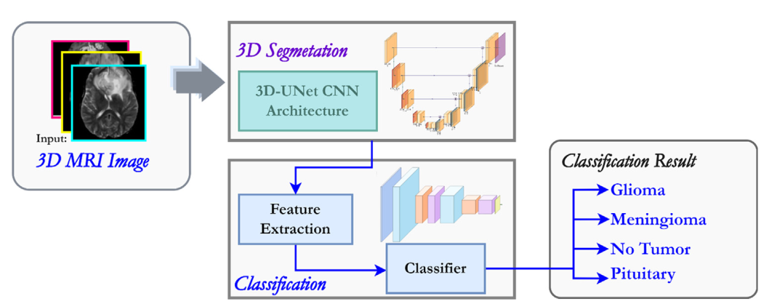

**Fig. 1. Abstract view of proposed Brain tumor Detection System.**

UNet architecture’s effectiveness has also been extensively documented in the biomedical literature.

The proposed work takes into account an image registration model, a 3D U-Net model, and finally a soft dice loss feature, all of which have been combined to form a comprehensive tumor detection model. The first move was to merge 3D image slices from an MRI scan into a single 3D model. Image registration corrects misalignment issues during mixing. The 3D model is divided into subsections after it has been developed.

The subsections are then passed into the U-Net model, and the segmented model is obtained at the output after both down and up convolution cycles. The subsections are then merged once more to create a segmented 3D model, followed by the estimation of the loss function.

After the volumetric segmentation of the tumor the next step is the classification of the brain tumors into meningioma, glioma, and pituitary tumors. Prior to feature extraction and sorting, most traditional brain tumor classification approaches included region-based tumor segmentation.

CNN is made up of a convolutional neural network that performs automated segmentation and feature extraction, supplemented by a classical neural network that performs classification. A Rectified Linear Unit (ReLu), a convolution, and a pooling layer make up CNN’s wellknown simple architecture.

The abstract view of the proposed framework is presented in Fig. 1. The MRI images will be used as the input. The main phases of the proposed system are divided into four parts:

i Data Collection

ii Pre-processing

iii Segmentation

iv Classification

Firstly, the collected images are subjected to the pre-processing module. The corrupted and blurred images are filtered in this module. For efficient and enhanced segmentation and classification, better segmentation and classification models are proposed in the research work.

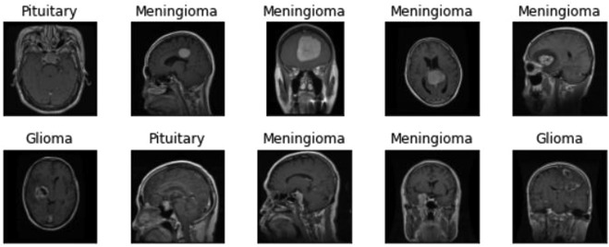

Fig.2 **[Types brain tumor](https://www.google.com/url?sa=i&url=https%3A%2F%2Fwww.sciencedirect.com%2Fscience%2Farticle%2Fpii%2FS2666307422000213&psig=AOvVaw2QYUBoQ-Mf8oREmRxA-3Vu&ust=1716965724694000&source=images&cd=vfe&opi=89978449&ved=0CBQQjhxqFwoTCNiQk_Phr4YDFQAAAAAdAAAAABAE" \t "_blank)**

The major contributions of the paper are as follows:

• The proposed framework incorporated the implementation of an advanced 3D U-Net model for volumetric segmentation and updated CNN for the classification of the MRI images, with the objective of creating an expert system for predicting brain tumors at an early stage.

• The proposed segmentation and classification models are empirically evaluated using various evaluation metrics such as precision, recall, F score, dice similarity co-efficient, and support.

• The loss and precision diagrams have also been used to establish the validity of the models.

• The results are compared with the other approaches reported in the literature, and established as being more efficacious than the state of-the-art techniques.

**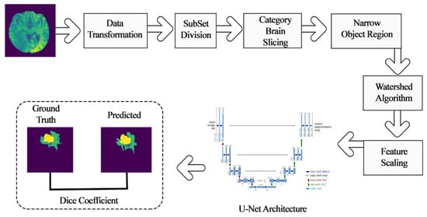**

**Fig.3. Process of classification of brain tumor**

**1.4.1 3D-UNet**

It is composed of a contractive and an expanding path, that aims at building a bottleneck in its centermost part through a combination of convolution and pooling operations. After this bottleneck, the image is reconstructed through a combination of convolutions and up sampling.

3D U-Net is a type of neural network architecture primarily used for volumetric image segmentation tasks, particularly in medical image analysis. It's an extension of the original 2D U-Net architecture to handle 3D volumes, which are common in medical imaging such as MRI, CT scans, and microscopy.

The "U" in U-Net refers to its U-shaped architecture, which consists of a contracting path (encoder) and an expansive path (decoder), with skip connections between them. These skip connections help to preserve spatial information during the downsampling and upsampling operations, aiding in better localization of features.

Contracting Path (Encoder): This part of the network extracts features from the input volume through a series of convolutional and pooling layers, reducing the spatial dimensions while increasing the number of feature channels.

The decoder upsamples the feature maps back to the original input size using transposed convolutions or upsampling layers. This process gradually recovers spatial information lost during the downsampling, and it typically involves concatenating feature maps from the contracting path at corresponding resolution levels to preserve fine-grained details.

These connections directly link the corresponding feature maps from the contracting path to the expanding path. By doing so, the network can combine low-level features (captured in the early layers) with high-level features (captured in the deeper layers), facilitating precise segmentation.

The 3D U-Net architecture has demonstrated state-of-the-art performance in various medical image segmentation tasks due to its ability to capture spatial dependencies in volumetric data effectively. However, it requires significant computational resources due to the 3D convolutions and larger memory footprint compared to its 2D counterpart. Nonetheless, its benefits in accurately segmenting 3D structures make it invaluable in medical image analysis.

3D-UNet is composed of a contractive and an expanding path, that aims at building a bottleneck in its centermost part through a combination of convolution and pooling operations. After this bottleneck, the image is reconstructed through a combination of convolutions and upsampling.

3D-UNet allows for seamless segmentation of 3D volumes, with high accuracy and performance, and can be adapted to solve many different segmentation problems. The following figure shows the construction of the 3D-UNet model and its different components. 3D U-Net segmentation is an architecture based on the Convolutional Neural Network (CNN), which has typical use to classify labels. However, in medical imaging, the desired output should be more than just classification.

**1.5 Related work**

Over the years, many specialists from diverse backgrounds have worked and are still working within the domain of image processing, dealing with the detection and classification of various cancerous diseases like brain tumor, kidney tumor etc., and have proposed many novel procedures to generate the best results.

Wadhwa, Bhardwaj and Verma (2019) examined various methods for tumor identification and proposed that combining Conditional Random Field (CRF) with FCNN and CRF with Deep Medic or Ensemble offers better performance than the other approaches for tumor segmentation.

In Özyurt, Sert, Avci and Dogantekin (2019), for segmentation, Fatih Zyurt et al., proposed the use of the neutrosophic set expert maximum fuzzy-sure entropy (NS-EMFSE) process, and SVM and KNN classifiers were used to remove segmented functionality from the CNN architecture.

Recently, CNN has been employed by many researchers for image classification in the domain of medical sciences (Ayadi, Elhamzi, Charfi, & Atri, 2021; Jin, Meng, Sun, Cui & Su, 2020; Kalaiselvi, Padmapriya, Sriramakrishnan & Somasundaram, 2020; Mohsen, El-Dahshan, El-Horbaty & Salem, 2018; Murthy, Koteswararao & Babu, 2022; Rehman et al., 2021; Suganthe, Revathi, Monisha & Pavithran, 2020).

Good performance results are reported using advanced neural network models for MRI scan classification (Liu et al., 2018; Abiwinanda, Hanif, Hesaputra, Handayani & Mengko, 2019; Afshar, Mohammadi & Plataniotis, 2018; Badža & Barjaktarović, 2020; Bedekar, Niharika Prasad, & Revati Hagir, 2018).

Automated classification is very useful in computer-aided diagnosis systems. Ensemble models combining SVMs and neural networks are also implemented for the design of medical diagnosis systems (Deepak & Ameer, 2021). Soft computing techniques like fuzzy logic are also incorporated for better results (Jayachandran & Dhanasekaran, 2013).

Advanced fuzzy methods like adaptive fuzzy C-means clustering are used for segmentation. Results are further improved by the deer hunting optimization algorithm (Murthy et al., 2022). Li, Kuang, Xu and Sha (2019) proposed a multi-CNN approach to tackle the poor performance offered by the conventional methods.

The conventional models have slow training rates and often suffer from overfitting. The proposed method uses 3D-MRI images to train the neural network for volumetric segmentation as compared to 2D-MRI images. The method employs the use of three-dimensional CNNs for this purpose for the volumetric detection of the tumor in the 3D-MRI images.

The work also concludes that instance normalization consumes less time to train the 3D-CNN as compared to batch normalization and group normalization methods, and the proposed 3D-CNN model for the brain tumor detection offers better accuracy and performance.

An algorithm for 2D MRI scans is also proposed for segmentation and classification of MRI scans. Deep neural network algorithms with different activation functions like SoftMax and sigmoid are also implemented (Chattopadhyay & Maitra, 2022). Some researchers have also deployed a user-friendly computer-aided interface for MRI scan classification (Ucuzal, Yaşar & Çolak, 2019).

Sobhaninia et al. (2018) suggested that medical image recognition relies heavily on image segmentation, because medical photographs are too diverse, and used MRI and CT scan images to segment the brain tumor. The most common use of MRI is for brain tumor segmentation and classification. They proposed the use of fuzzy C-Means clustering for tumor segmentation, which can reliably model tumor cells.

After segmentation, classical classifiers and CNNs were used to classify the data. They implemented and compared the effects of various conventional classifiers such as K-Nearest neighbour, logistic regression, multilayer perceptron, nave bayes, random forest, and support vector machine in the traditional classifier section. SVM had the best precision of 92.42 percent among these conventional ones.

They also introduced CNN, which yielded 97.87 percent accuracy with a split ratio of 80:20 of 217 photographs, and suggested to experiment with 3D brain images in the future to accomplish more effective brain tumor segmentation.

Working with a wider dataset would be more difficult in this regard, and they aspired to create a dataset that emphasizes the abstract in relation to their region, which will help them expand the reach of their research. In Zhou et al. (2020), a web-based application that can identify brain tumor (glioma, meningioma, and pituitary) based on high-precision T1 contrast MRI with CNNs.

It is hoped that the free web-based software would enable medical professionals and other health professionals to identify brain tumors more quickly and accurately. In this regard, the app can be used as a clinical-decision support method for brain tumor classification (i.e., glioma, meningioma, and pituitary).

According to the experimental findings, all of the measured success metrics for classifying the forms of brain tumors on the training dataset were greater than 98%. On the research sample, all performance metrics are greater than 91%, with the exception of the sensitivity and Matthews correlation coefficient (MCC) performance metrics for meningiomas.

When the measured efficiency metrics from the CNN model's training and testing stages are considered, the proposed model is capable of effectively classifying various brain tumor forms. A new research study created the CNN to identify brain tumor on public data sets, with 233 and 73 patients, and 3064 and 516 images on T1-weighted magnetic resonance images.

For the two datasets, the method built in this trial performs significantly better and is able to effectively identify brain tumor multi-classification jobs at the highest overall accuracy levels of 96.13% and 98.7% respectively. A new algorithm for the classification of brain tumor in Grade I, Grade II, Grade III and Grade IV of the CNN profound learning algorithm was also developed.

The proposed algorithm for deep learning consists of three steps: a) tumor segmentation, b) data increase, and c) profound extraction and classification functions. Experimental findings from the other research work were investigated and showed that, when extended to augmented and initial data sets, the proposed algorithm has greater efficiency than the present methods.

The classification and simulation of T1-weighted MRI of brain tumor were well performed during previous experiments in machine learning and deep learning algorithms. But the selection and development of these algorithms may take a lot of time and experience if we consider the machine learning and data mining applications of the studies published over the past few years.

Therefore, in recent years, automated machine learning and various modelling systems have been widely developed. To put it briefly, the current research introduces a novel public web-based program to identify brain tumor types based on CNN's profound learning algorithms for T1-weighted MR images.

Yadav and Sahu (2013) presented a novel approach for the automatic segmentation of the most popular brain tumor, including gliomas, meningiomas, and pituitary. No preprocessing steps are essential for this technique. The findings show that angle-based dividing of photographs increases dividing precision.

The highest score for the dice was 0.79. The tumor segmentation in sagittal view images provided this comparatively high ranking. Other organs are not visible in sagittal images, and the tumor is more pronounced than in other images. The photographs from the axial view of the head received the lowest dice score in their tests, which has been reported as 0.71.

The axial view provides less specificity than the other pictures. It is anticipated that preprocessing this group of images would result in improved tumor pixel classification and an improvement in the dice ranking. The presented approach may be used to segment brain tumor in MRI images as an easy and practical technique for doctors.

In Murthy and Sadashivappa (2014), MRI studies indicate that the cancer-affected region has very high intensity pixels, whereas normal tissue has low intensity pixels. Thresholding is a method of segmentation that uses only the sensitivity parameter. This is one of the most basic types of segmentation, in which the tumor is classified according to its grey level.

Area-based image segmentation (Alqudah, Alquraan, Qasmieh, Alqudah & Al-Sharu, 2020) involves developing regions. Method uses 4-connected neighborhood or 8-connected neighborhood methodology. The amplitude of the same picture is clustered in one area. If the intensity belongs to the same seed, the phase is iterated, and the intensity belongs to one field.

Geometric active contour models focused on regions are more resistant to noise in the MRI, which leads to poor segmentation. T.S. Deepthi Murthy et al. (Kaur & Gandhi, 2019) proposed thresholding and morphological operations that are used to perform effective brain tumor segmentation.

However, since the threshold value used is a global threshold, it is not completely automatic and requires human interference. In Kavita, Alli and Rao (2022), a study has been presented on the multimodal medical image fusion technologies using pulse coupled neural networks with QCSA and SSO optimization techniques.

In Kalaivani and Seetharaman (2022), a three-stage boosted ensemble convolutional neural network has been proposed for the classification of COVID-19 chest x-ray images. The proposes the development of an extended U-Net architecture using ResNet architecture as a backbone. In Muruganantham and Balakrishnan (2021), a survey has been carried out for the various deep learning methodologies used to detect various gastrointestinal tract diseases.

**1.6 Deep Learning**

**1.6.1 Deep Learning:**

Deep learning is a subset of machine learning that focuses on training deep neural networks with multiple layers to learn and represent complex patterns in data. Deep neural networks are composed of interconnected layers of artificial neurons that simulate the structure and functioning of the human brain.

Deep learning is a branch of machine learning which is based on artificial neural networks. It is capable of learning complex patterns and relationships within data. In deep learning, we don’t need to explicitly program everything. It has become increasingly popular in recent years due to the advances in processing power and the availability of large datasets. Because it is based on artificial neural networks (ANNs) also known as deep neural networks (DNNs). These neural networks are inspired by the structure and function of the human brain’s biological neurons, and they are designed to learn from large amounts of data.

**1.6.2 Key aspects of deep learning include:**

* Neural Networks: Deep learning relies on neural networks with multiple hidden layers, allowing the network to learn hierarchical representations of the data. Each layer in the network extracts higher-level features from the representations learned in the previous layer. Deep neural networks can automatically learn and extract relevant features from raw data, eliminating the need for manual feature engineering.
* Training Process: Deep learning models are trained through a process called back propagation, where the network adjusts its internal parameters (weights and biases) to minimize the difference between the predicted output and the target output. This process involves propagating errors backward through the network and updating the parameters using gradient descent optimization algorithms.
* Large-Scale Data: Deep learning models typically require a large amount of labeled data for training. The availability of big data and advances in computing power have enabled the success of deep learning models. The large-scale data allows deep neural networks to learn complex representations and generalize well to new, unseen data.
* Applications: Deep learning has shown remarkable performance in various fields, including computer vision, natural language processing, speech recognition, and recommendation systems. It has achieved state-of-the-art results in tasks such as image classification, object detection, machine translation, and speech synthesis.
* Deep learning excels in handling complex and high-dimensional data, capturing intricate patterns, and achieving state-of-the-art performance in many AI tasks. However, it typically requires more computational resources and data compared to traditional machine learning approaches.

In summary, machine learning focuses on training algorithms to learn patterns and make predictions or decisions, while deep learning is a specific approach within machine learning that utilizes deep neural networks to learn complex representations. Deep learning has gained significant attention and has been particularly successful in solving tasks that involve complex data such as images, audio, and text.

Lane detection using deep learning is a popular approach that leverages the power of deep neural networks to detect and track lane markings on the road. Deep learning models excel in learning complex patterns and can effectively capture the distinctive characteristics of lane markings, making them well-suited for this task. Here is a high-level overview of the lane detection process using deep learning:

* Dataset Preparation: The first step is to collect or create a dataset of labeled images or videos, where the lane markings are manually annotated. The annotations typically involve marking the pixels or regions corresponding to the lane markings in the images or videos.
* Data Pre-processing: The collected dataset is pre-processed to prepare it for training. This may involve resizing the images, normalizing pixel values, and splitting the dataset into training and validation sets.
* Model Architecture: A deep learning model architecture needs to be selected or designed for lane detection. Convolutional Neural Networks (CNNs) are commonly used due to their ability to capture spatial dependencies in images. The model architecture may consist of multiple convolutional layers followed by pooling, fully connected layers, and output layers.
* Training: The deep learning model is trained using the labeled dataset. The training process involves feeding the input images into the model, comparing the predicted output (lane markings) with the ground truth annotations, and updating the model's weights through back propagation and gradient descent optimization algorithms. The objective is to minimize the difference between the predicted output and the ground truth annotations.
* Post-processing: Once the model is trained, the lane detection results may undergo post-processing steps to refine the detected lane markings. This may include techniques such as filtering outliers, curve fitting, and extrapolation to extend the detected lanes.
* Evaluation and Testing: The trained model is evaluated on a separate test dataset to assess its performance. Evaluation metrics such as accuracy, precision, recall, and F1 score can be used to measure the model's lane detection performance.
* Deployment: The trained lane detection model can be deployed in real-time applications, such as autonomous vehicles or advanced driver-assistance systems (ADAS), to detect and track lane markings in real-world scenarios.

It's worth noting that there are different variations and approaches for lane detection using deep learning, including single-image-based methods and video-based methods. Additionally, techniques like semantic segmentation and instance segmentation can also be employed to precisely detect and differentiate lane markings from other objects on the road.

Deep learning-based lane detection has shown promising results and has been successfully applied in various real-world applications. However, it's important to fine-tune and validate the model on diverse datasets and consider factors such as different weather conditions, road types, and lighting variations to ensure robust and reliable lane detection performance.

**1.6.3 Application of Deep learning**

Deep learning is a subset of machine learning that uses artificial neural networks (ANNs) to model and solve complex problems. It is based on the idea of building artificial neural networks with multiple layers, called deep neural networks, that can learn hierarchical representations of the data.

Deep learning algorithms use a layered architecture, where the input data is passed through an input layer and then propagated through multiple hidden layers, before reaching the output layer. Each layer applies a set of mathematical operations, called weights and biases, to the input data, and the output of one layer serves as the input to the next.

The process of training a deep learning model involves adjusting the weights and biases of the model to minimize the error between the predicted output and the true output. This is typically done using a variant of gradient descent, an optimization algorithm that adjusts the weights and biases in the direction of the steepest decrease in the error.

Deep learning has a wide range of applications, including image and speech recognition, natural language processing, and computer vision. One of the main advantages of deep learning is that it can automatically learn features from the data, which means that it doesn’t require the features to be hand-engineered. This is particularly useful for tasks where the features are difficult to define, such as image recognition.

**1.6.4 Advantages of Deep Learning:**

Deep learning has several advantages over traditional machine learning methods, some of the main ones include:

1. **Automatic feature learning:**Deep learning algorithms can automatically learn features from the data, which means that they don’t require the features to be hand-engineered. This is particularly useful for tasks where the features are difficult to define, such as image recognition.
2. **Handling large and complex data:** Deep learning algorithms can handle large and complex datasets that would be difficult for traditional machine learning algorithms to process. This makes it a useful tool for extracting insights from big data.
3. **Improved performance:**Deep learning algorithms have been shown to achieve state-of-the-art performance on a wide range of problems, including image and speech recognition, natural language processing, and computer vision.
4. **Handling non-linear relationships:**Deep learning can uncover non-linear relationships in data that would be difficult to detect through traditional methods.
5. **Handling structured and unstructured data:** Deep learning algorithms can handle both structured and unstructured data such as images, text, and audio.
6. **Predictive modeling:**Deep learning can be used to make predictions about future events or trends, which can help organizations plan for the future and make strategic decisions.
7. **Handling missing data:** Deep learning algorithms can handle missing data and still make predictions, which is useful in real-world applications where data is often incomplete.
8. **Handling sequential data:** Deep learning algorithms such as Recurrent Neural Networks (RNNs) and Long Short-term Memory (LSTM) networks are particularly suited to handle sequential data such as time series, speech, and text. These algorithms have the ability to maintain context and memory over time, which allows them to make predictions or decisions based on past inputs.
9. **Scalability:** Deep learning models can be easily scaled to handle an increasing amount of data and can be deployed on cloud platforms and edge devices.
10. **Generalization:**Deep learning models can generalize well to new situations or contexts, as they are able to learn abstract and hierarchical representations of the data.

**CHAPTER 2**

**LITERATURE SURVEY**

Principal component analysis is applied for image segmentation but the accuracy is 76.6%. Neural networks works better for image enhancement and image segmentation but the algorithm wont work better in case of noise. The accuracy of basic neural network is less in case of noise.Multiple techniques need prior knowledge for segmentation which is not possible every time. To Design & Implement a technique for Automatic enhancement and segmentation of cardiac region from full cardiac image.

In the paper object segmentation is done with the help of shape driven information.Shape understanding by hierarchical approach gives training to the deep boltzman machine[1].The local as well as global strcture is used to identify shape variations based on learned model of hierarchical architecture.Shape distribution uses the data driven method to extract the object from given corrupted image. Proposed work works better for corrupted data , occulded data as well as noisy data.The CDR(correct detection rate) is not upto the mark for given model.

Exact detection and segmentation for anatomical ultrasound images is one of the important application required[2].Ultrasound images are having many different advantages like portability and low cost.But due to complex structure it is difficult to detect and segment regions exactly.So author designed Deep learning approach for regularization in multi-domain.Results obtained are improved by iterative process which may take more time compared to state of art techniques is the major drawback of proposed work.Compared to human understanding definitely it behave more accurate and also it work for huge image databases.

The author worked with histopathological images to detect and segment the essential part from the image[3].Author showed that the existing methods are having drawbacks of time consuming,error-prone as well as depends on operator.In oder to overcome all the existing challenges DCAN(Deep counter aware network) is proposed by author[3] for better accuracy and perfect segmentation.Also end to end convoltion network is proposed for better accuracy of segmentation.In this auxialary supervision is performed to overcome vanishing gradients while training network.The proposed work by author works on2015 MICCAI Gland Segmentation Challenge database and show the superior performance of proposed method.

**[1] “What regularized auto-encoders learn from the data-generating distribution,” Guided by G. Alain and Y. Bengio, by the year of 2014.**

assessment, an ordinary strategy intertwine name clinical picture examination assignments. Thusly, getting ready technique progressively significant desires, explicitly in circumstances where the data picture data isn't helpful or unsurprising enough (for instance missing thing limits). Even more essentially, clearly, this is most likely the soonest study displaying the use of convolutional auto encoder frameworks to take fit as a fiddle assortments from clinical pictures. The secluded cardiovascular appraisal up: cardiovascular picture division instead of past.

**[2] “A combined deep learning and deformable-model approach to fully automatic segmentation of the left ventricle in cardiac MRI,” Implemented by M. R. Avendi, A. Kheradvar, by the year of May 2016.**

Division of the left ventricle (LV) from cardiovascular appealing resounding imaging (MRI) datasets is a fundamental improvement for check of clinical records, for example, ventricular volume and discharge part. Right now, utilize critical learning estimations got along with deformable models to make and study a completely modified LV division mechanical get together from short-turn heart MRI datasets. The technique utilizes huge learning figurings to take in the division task starting from the soonest stage information. Convolutional structures are utilized to ordinarily perceive the LV chamber in MRI dataset. Stacked auto encoders are utilized to gather the LV shape. The discovered shape is consolidated into deformable models to improve the exactness and nature of the division. We asserted our methodology utilizing 45 cardiovascular MR datasets from the MICCAI 2009 LV division challenge and exhibited that it beats the forefront systems. Unimaginable concurrence with the ground truth was developed. Support estimations, level of good shapes, Dice metric, standard converse division and likeness, were taken care of as 96.69%, 0.94, 1.81 mm and 0.86, versus those of 79.2 − 95.62%, 0.87–0.9, 1.76–2.97 mm and 0.67–0.78, secured by different systems, autonomously. In theoretical, a novel strategy for completely altered LV division from cardiovascular MRI datasets is appeared. The method utilizes critical learning figuring’s for modified zone and finding the LV shape. The shape was cemented into deformable models and brought more strength and exactness, especially for testing basal and apical cuts. The portrayed procedure is demonstrated to be exact and strong stood apart from the other front line systems. Electrifying understanding and a high relationship with reference structures are picked up. Of course with other robotized approaches, our strategy depends after learning a few degrees of portrayals, relating to a pecking order of administration of highlights and doesn't envision any model or suspicion about the picture or heart. The practicality and execution of this division procedure is enough showed up through taking care of support estimations concerning the best level on the MICCAI 2009 database (Radau et al., 2009). Testing our strategy on a more prominent course of action of clinical information is subject of future research.

**[3] “Automatic segmentation of the right ventricle from cardiac MRI using a learning-based approach,” Produced by M. R. Avendi, A. Kheradvar, by the year of 2017.**

The vast majority of the difficulties for RV division is a consequence of the astonishing life systems of the. join forces like, radiant bow state changes zenith, also arrangement power. Taking into account difficulties, just assessments concentrated division. top level frameworks for RV division experience the underhanded effects of a few hindrances, for example, spillage and shrinkage of structures because of the fluff edges closeness trabeculations. technique vanquished deficiencies and confined shrinkage/spillage by sorting out the collected fittingly conveyed pinnacle. Essentially as different techniques in the synthesis (6), the massive structures can be significantly more precisely apportioned separated and the little structures, and working with picture cuts in territory of the apex especially at ES can be trying an immediate aftereffect of the little size and sporadic shape.

Arranged estimations in Table 1 show that the structures at ED were significantly more precisely isolated the degree that DM separated and the shapes general considering the way that shapes at ES are more prominent and increasingly direct to segment. Once more, this is in like way an attribute of other division frameworks as organized in petit jean et al (6). Table 2 solidifies the enrolled quantitative estimations appeared at the midpoint of strategy beats top level strategies. Mean DM updates separated and different frameworks run assessment uncovered unimportant tendencies and a dominating degree of perception separated and that of different techniques. For instance, the Bland Altman follows identified with EF displayed a propensity near zero with the 95% farthest reaches of appreciation ( 6 1.96 SD) very nearly 6 0.10. This presentation takes after what organized.

Manuals encode noteworthy anatomical and significant data from a mass. Right now, biventricular cardiovascular chart book was worked from a stand-apart instructive grouping, which incorporates critical guidelines heart MR pictures of 1000+ standard subjects. Considering the outline book, genuine methods were utilized to take a gander at the collection of cardiovascular shapes and the dissipating of heart improvement over the spatio-transient district. indicated honest gotten along straight think about effect sexual bearing territorial divider. At long last, in like way broke down the impact of the individual’s size on map book improvement and layout book based assessment. The huge principles map book, the genuine models and the SPM framework will profit more evaluations on heart life structures and breaking point assessment later on. As of now, developed the graph book pictures must seen solid. Thusly, manual quantifiable data sound addresses average life structures improvement. Regardless, give beginning stage to pondering the sporadic life structures and improvement. For instance, the picture work changed as per setup separated and normal.

In like way, the improvement of the patient can in like way be accustomed to the setup space, with the target that remarkable advancement models might be perceived utilizing the bona fide advancement model of the normal's, for example, the. Disclosure remarkable divider impossible to miss improvement design is a dazzling bearing. Investigated all-inclusive masses outcomes genuine force, significant assessments, instance, considers appraisals. Specific point of view, a test that we face in managing a colossal instructive record is the all-encompassing extent of manual intercession. As of now, spots of intrigue are utilized to introduce the picture choice. Future work is depended upon to dislodge this part with solid and motorized picture enlistment by strategies for accomplishment divulgence or organ restraint.

Besides, fused outline picture division significant coming about genuine assessment since the myocardial divider thickness is figured from the division. Once more, a computerized quality control system is required if this or comparable procedures are to be sent for much more noteworthy educational records, for instance, for experiences, for example, the UK Biobank4, which is proposing to look over to 100,000 subjects.

As of now, enlistment is performed going before assessing the game plan picture. An elective course for map book progression is to join picture selection and arrangement structure Leem put, methodology pack smart picture enrollment and diagram book update. Regardless, GroupWise picture determination can be computationally over the top for a gigantic enlightening record. Right now, perform subject-wise picture choice and check the graph book some time later. For building a sensible graph book, we figure the mean of the nonrigid changes utilizing dealing with figures clearing.

Precisely enormous clearings open, in any case, ceaselessly suitable process utilizing structure, for example speed proposed Ash burner choice expected unimaginably enormous distortion might be thought of. Illuminating record, photographs solid . discovered in wake of evacuating the relative parts, the extra non-unbending changes between solid subjects are near nothing. Right now, the Euclidean mean can be a middle of the road theory. There are various systems for pre-managing before quantifiable appraisal cross sections. instance, bearing contrasts cross areas.

**[5] W. Bai et al., “A probabilistic patch-based label fusion model for multiatlas segmentation with registration refinement: Application to cardiac MR images,” IEEE Trans. Med. Imag., vol. 32, no. 7, pp. 1302–1315, Jul. 2013.**

The appraisal of ventricular limit is noteworthy for the investigation of cardiovascular afflictions. It normally incorporates estimation pit. layout structures repetitive the enthusiastic experience of the ace map book strategy heart alluring resonation picture division. procedure perspectives. In the place, characterizes fix name mix picture selection precision name information, prompts division surveyed heart picture typical spread measurement division wretchedness, benefit pit strategy can give exact information to clinical investigation. In the examinations, we have found that selection precision significantly influences division execution. With enrollment refinement, mark blend. Besides, enlistment qualification between name blend procedures gets unnoticeable. Without a doubt, even lion's offer throwing a voting form can perform very well for this circumstance. Regardless, if the enlistment isn't amazingly exact, for example when relative selection is used, refined name blend frameworks, for instance, the fix based technique accept a huge activity in improving division execution. a guide book fix are resolved, the spread can achieve smooth assortment of the heaps and in like manner smooth assortment of the name map measure.

**[7] “Topology aware fully convolutional networks for histology gland segmentation,” Produced by A. BenTaieb and G. Hamarneh, by the year 2016.**

The progressing achievement of significant learning techniques all together and article distinguishing proof assignments has been used for division tasks. Regardless, a weakness of these significant division models is their limited ability to encode raised level shape priors, for instance, flawlessness and assurance of complex relationship between object territories, which can realize fantastical divisions. In this work, by characterizing and smoothing out another setback, we present the principle significant framework arranged to encode geometric and topological priors of control and partition. Our results on the division of histology organs from a dataset of 165 pictures display the upside of our novel disaster terms and show how our topology careful plan pounds fighting systems by to 10% in both pixel-level accuracy and article level Dice.

We guessed that the thought of before data in the readiness of significant totally convolutional frameworks for the division of histology organs can achieve progressively exact divisions. To test our theory, we presented a novel adversity work inspired by essentialness based models for multi-area checking and balanced for significant frameworks. Our revelations show that our system yields on a very basic level dynamically exact and possible divisions while being even more computationally profitable at test-time. We plan to furthermore investigate the effect of furnishing significant learning models with huge prior data for getting ready more regularized sorts out on different clinical division applications.

**[8] “Segmentation algorithms in 3D Standardized evaluation system for left ventricular echocardiography,” Authorized by O. Bernard, By the year of Apr. 2016.**

Steady shown exact gadget. Regardless, conspicuous verification troublesome endeavor, essentially separation photos got together regular antiquated rarities. A couple of semi and totally modified figuring’s dividing evacuate records, yet methodical sensible connection strategies incomprehensible on account of the nonappearance of a straightforwardly open essential database. Here, we familiarize a standardized evaluation structure with constantly survey and break down the introduction of the figuring’s made edge involving heart narratives concentrations relating estimations figuring’s bundles surveyed taken a gander at stage. concerning pros' estimations records, incredible division regards to partition botch with respect to the masters' irregularity run. The stage remains open for new sections.

A straightforwardly open standardized evaluation framework to consider the introduction of endocardial division methodology in RT3DE was presented in this article. The results exhibited current figuring’s in regards authorities' estimations records, extraordinary division exactness to the extent mean partition botch with respect to the pros' change pursue accord understanding. In spite of the way that these results are enabling, they also reveal that there still exists chance to improve.

**[9] “Deep learning shape priors for object segmentation,” Produced by F. Chen, and X. Zeng, by the year of Jun. 2013.**

This paper were present another system as the object division. readiness initially significant pick up capability with the different leveled designing of shape priors. This informed different leveled building show assortments as well as worldwide or neighborhood enthusiastic structure. Assessments display abstract adjust to picture upheaval and wreckage, similarly as fragmentary obstacles. Our strategy involves significant Boltzmann machine to isolate as the different leveled planning structure. That different leveled structure can reasonably get worldwide and close by structures of prior shapes. During the second stage a shape-driven variational structure is manufactured genuinely on the space of shape probabilistic depiction. This dynamic structure of shape prior is familiar in an eager structure with regularize the target shape in variational picture division. We show the practicality of the ensuing figuring in segmenting pictures that incorporate low-quality data and hindrances.

**[10] “DCAN: Deep contour-aware networks for object instance segmentation from histology images,” Produced by H. Chen, and P.-A. Heng, by the year Feb. 2017.**

The morphology of organs has been used routinely by pathologists to study the danger level of adenocarcinomas. Exact division of organs from histology pictures is a crucial development to get reliable morphological estimations for quantitative examination. In this paper, we proposed a compelling significant structure careful framework (DCAN) to deal with this troublesome issue under a bound together perform different assignments learning structure. In the proposed orchestrate, amazed intelligent features from the different leveled configuration are examined with right hand the executives for exact organ division. Right when united with perform different assignments regularization during the arrangement, the discriminative capacity of midway features can be furthermore improved. Moreover, our framework can yield exact probability maps of organs, yet furthermore depict clear structures simultaneously for secluding grouped articles, which further lifts the organ division execution.

This united structure can be powerful when applied to colossal extension histopathological data without relying upon additional steps to make structures reliant on low-level finishes paperwork for post-secluding. Our methodology won the 2015 MICCAI Gland Segmentation Challenge out of 13 genuine gatherings, beating the different systems by a critical edge. In this paper, we have presented a significant structure careful framework that consolidates amazed consistent features to absolutely part organs from histology pictures. As opposed to learning organ division in withdrawal, we figured it as a united play out various assignments learning process by handling the corresponding information, which helps with advancing separate the gathered organ questions beneficially. Wide test results on the benchmark dataset with rich connection results showed the exceptional execution of our procedure. Later on work, we will upgrade the strategy and research its ability for huge extension histopathological dataset.

**[12] “3D U-Net: Learning dense volumetric segmentation from sparse annotation,” Produced by A. Abdulkadir, and O. Ronneberger, by the year of 2016.**

This paper presents a framework for volumetric division that gains from meagerly remarked on volumetric pictures. We plot two engaging use examples of this procedure: (1) In a semi-modernized plan, the customer remarks on specific slices in the volume to be segmented. The framework gains from these sparse remarks and gives a thick 3D division. (2) In a totally modernized course of action, we acknowledge that a representative, inadequately remarked on planning set exists. Arranged on this educational assortment, the framework thickly pieces new volumetric pictures.

**[13] “Combining point distribution models with shape models based on finite element analysis,” Developed by T. F. Cootes and C. J. Taylor, By the year 1995.**

This paper depicts a method for joining two different ways to manage exhibiting versatile articles. Measured Analysis using Finite Element Methods (FEMs) makes a great deal of vibrational modes for a Éêëèíî shape. Point Distribution Models (PDMs) make a genuine model of shape and shape assortment from a Éîï of model shapes. Another strategy is depicted which makes vibrational modes when barely any model shapes are open and changes effectively to using progressively quantifiable techniques for assortment when a colossal enlightening record is presented. Results are given for both made and authentic models. Tests using the models for picture search show that the solidified variation performs better than either the PDM or FEM models alone. The system depicted above licenses us to solidify the shape variability chose detail istically from a planning set with that delivered erroneously by building a 'physical' model of the objects of interest. Exactly when only a singular model is open just FEM modes are used. As more models are incorporated, the quantifiable depiction of the shape assortment.

**[14] C. Davatzikos, X. Tao, and D. Shen, “Hierarchical active shape models, using the wavelet transform,” IEEE Trans. Med. Imag., vol. 22, no. 3, pp. 414–423, Mar. 2003.**

Dynamic shape models (ASMs) are much of the time weaknesses reasonably get extent natural capriciousness. Methodology dynamic specifying dynamic change. Quantifiable change shape penniless somewhere near methods for head part assessment, and used as priors in the structure's misshapening. A part of respectably overall as far as possible, however, some of them get close by and high-repeat shape traits and, as such, fill in as neighborhood flawlessness necessities. This arrangement achieves two goals. In the first place, it is solid when only a foreordained number of getting ready tests is available. Second, by using close by bits of knowledge as flawlessness constraints, it forgoes the necessity for getting uncommonly designated physical models, for instance, adaptability or distinctive flawlessness models, which don't generally reflect authentic normal vacillation. Models on alluring resonation photos of the corpus callosum and hand structures show that incredible and totally electronic divisions can be cultivated, even with as very few as five getting ready tests. We presented a different leveled plan of dynamic quantifiable going before have the alternative to get fine similarly massacres hindrances past reliant arrange.

Different leveled depiction with respect to change trailed explanation technique though for the most part humble number of getting ready tests can't generally get the high-dimensional probability thickness. . The realities affirm that if certain assortment of the shape isn't presented in the readiness tests. By then paying little heed to what number of tests set up it incredibly improbable assortment. Legitimate unique yet. In any case, techniques offer deal with all more probable depicts the assortments readiness tests. Furthermore depicted continuously relies upon grungy depiction. As gives as well as nature twist depiction some degree distorted way to deal with amass different leveled dynamic shape model. Procedure 2 relies upon the wavelet rot. It has an exhaustive logical establishment, and the multiresolution chain of significance noteworthy

**CHAPTER 3**

**PROPOSED METHOD**

The proposed segmentation and classification models are explained in this section.

**3.1. Segmentation model**

**i. Dataset**

In multimodal magnetic resonance imaging (MRI) scans, BraTS has always concentrated on evaluating cutting-edge techniques for brain tumor segmentation. BraTS 2020 segments intrinsically heterogeneous (in appearance, shape, and histology) brain tumors, such as gliomas, using multi-institutional pre-operative MRI scans.

BraTS'20 also uses integrative analyzes of radiomic features and machine learning algorithms to pinpoint the clinical validity of this segmentation task, as well as estimate patient overall survival and the discrepancy between faux progression and actual tumor recurrence. Finally, BraTS'20 attempts to evaluate the algorithmic sophistication of tumor segmentation.

i 3D-Unet U-Net is one of the most popular architectures used for segmentation. It was designed for image segmentation in the biomedical field. It produced great results for cell tracking. It can work with hundreds of examples and produce good results. As it is U-shape so it is called the U-net model.

It consists of two paths: the contracting path and the expanding path. Both paths perform opposite results. The contracting path involves down sampling and down convolution. Expanding paths involves up-sampling and up-convolution. In contracting path feature maps get spatially smaller, whereas in an expanding path, the feature maps are expanded back to their original size.

This model was basically built for 2D images, but by replacing 2D convolutional networks with 3D networks the model can be used for 3D convolution as well. Fig. 2 shows the architecture of the 3D-Unet deep neural network architecture.

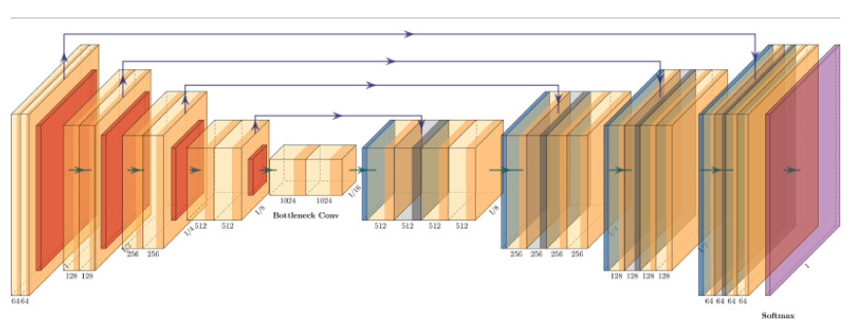

**Fig. 4. 3D-UNet structure.**

The 3D U-Net model is the model introduced in this paper. The models that make up the full tumor detection platform are an image registry model, a 3D U-Net model, and soft dice failure. The first step was to combine 3D image slices from an MRI scan into a single 3D model. Image registration is used to solve misalignment issues during combination.

Following the formation of the 3D model, the 3D model is divided into subsections, each of which is coded in the appendix. The subsections are then fed into the U-Net model, which produces the segmented model after all of the down and up convolution cycles. The subsections are then merged once more to create a segmented 3D model. The next move is to calculate the damage. 3.2. Classification model

**3.1.1. Dataset**

The classification model is based on the Brain tumor Classification (MRI) Kaggle dataset. This dataset is split into training and research sets, accumulating 3264 files categorized as glioma, meningioma, pituitary, and no tumor photographs. Since this is a classification model, this dataset aids in the accurate and precise training and testing of the model.

**3.1.2. Convolutional neural network**

Neural network architecture is inspired by the biological human brain. Neural networks are primarily used to quantify vectors, approximate data, cluster data, align patterns, optimize, and classify functions.

Based on their links, the neural network is categorized into three groups, viz., (a) feedback, (b) feedforward, and (c) recurrent networks. Further, a neural network can be classified as a single-layer network or a multilayer neural network.

The picture cannot be scaled in the standard neural network. However, in the convolution of the neural network, pictures can be scaled (i.e. in length, width, and height). The Convolution Neural Network (CNN) consists of an input layer, a convolution layer, and a rectified linear unit (ReLu).

The provided input picture is divided into several small regions of the convolution sheet. In the ReLu layer, element-wise feature activation is performed, and an optional pooling layer could be used. The pooling layer is used primarily for sampling purposes.

A class score or mark score value dependent on chance between 0 and 1, is used in the last layer (i.e., to produce the completely connected layer). Fig. 3 shows the block diagram of the grouping of brain tumor based on the neuronal network. The classification of brain tumor based on CNN is split into two stages: (a) preparation and (b) research.

The number of photographs is categorized by naming the marks (tumor, non-tumor images, etc.) into various categories. In the training step, pre-processing, functional extraction and loss function classification are carried out to produce a prediction model.

First, the picture collection is marked for the instruction, and then the image is resized to adjust the image size in the pre-processing process. Finally, for the automated detection of brain tumor the neural convolution network is used.

**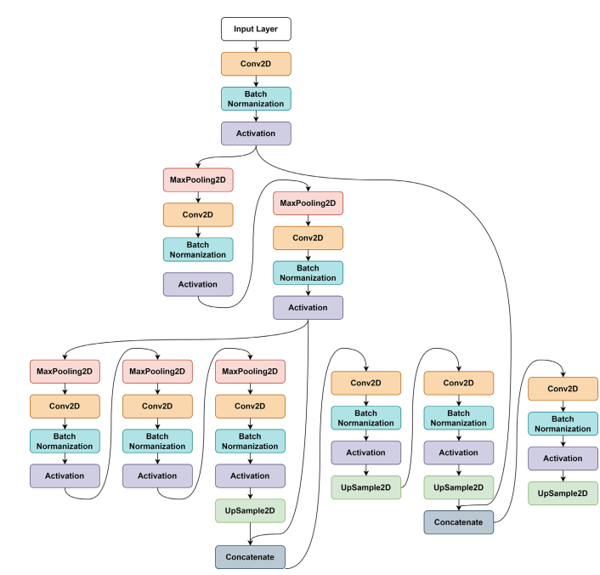**

**Fig. 5. Segmentation and Detection model.**

The brain image dataset used for this model is taken from Kaggle. To use the untrained dataset, the model is trained from layer one until the end layer. This can be very time-consuming and will also affect the outcome. So, for classification measures, a pre-trained model-based brain dataset is used to prevent this issue.

In the proposed model, only the last layer is trained during implementation. As a result, the proposed model has a short computing period with higher efficiency. The loss function is determined by the gradient descent algorithm. The raw pixel image is mapped using a score feature to achieve class results. Quality is calculated by the loss function of a particular set of parameters.

It is dependent on the way induced results are accepted in the training data with the ground truth marks. In order to increase the precision, calculating the loss function is extremely necessary. When there is a high loss function, the precision will be very poor. Similarly, when the loss function is minimal, the precision will be high. The value for the loss function is determined to estimate the downward gradient algorithm, and it accesses the gradient value to calculate the loss function gradient repeatedly.

**3.1.3. Proposed segmentation model**

The proposed model in this paper is a newly developed CNN architecture. The proposed architecture is novel because it is updated. The design has 16 layers to enable the classifier to efficiently classify the brain tumor images. The configuration of the implemented CNN architecture is presented in Fig. 4.

**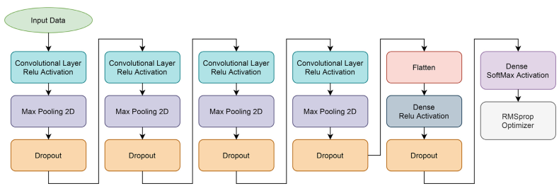**

**Fig. 6. Proposed Classification Model.**

**3.2 Flowchart for proposed method**

Selection of dataset

Pre-processing

Segmentation

Feature extraction

Classification

Prediction of single image

**Fig. 7 Flowchart of proposed method**

# **CHAPTER 4**

**SOFTWARE AND HARDWARE REQUIRMENT**

**4.1 HARDWARE REQUIREMENTS:**

* System : Pentium Dual Core.
* Hard Disk : 120 GB.
* Monitor : 15’’ LED
* Input Devices : Keyboard, Mouse
* Ram : 4 GB

**4.2 SOFTWARE REQUIREMENTS:**

* Operating system : Windows 10
* Coding Language : python
* Tool : Python
* Database : dataset
* Server : Flask

**4.3 Hardware Interfaces**

Intel Core i5 2.00GHz Processor or each and every other processor and 200 GB min RAM 20GB Hard plate, and mouse is required.

**Software Interfaces**

The Python IDLE is an open-supply web utility that allows you to make and charge records that be essential for stay code, circumstances, portrayals, and story-printed content. Uses encompass realities cleansing and exchange, numerical re-establishment, quantifiable illustrating, realities conviction, framework examining, and divides

**CHAPTER 5**

**RESULT**

Brain tumor is a deadly disease which causes death to millions every year and timely detection of such tumor can help in reducing risk of losing life. In the past many deep learning algorithms were introduced which can detect tumor and perform classification but its detection rate is low and work only 2 dimension MRI images. Latest technology generating MRI in 3D format and existing UNET segmentation cannot work on 3D MRI images and to solve this issue author of this paper employing 3D-UNET algorithm which will segment out tumor part from brain MRI and then employing 16 layer CNN algorithm to classify or damage brain tumor.

3D-UNET algorithm trained on BRATS2020 dataset to segment out tumor data and then propose 16 layer CNN algorithm trained on ‘Brain Tumor MRI Dataset’ which consists of 4 different classes listed below

'glioma', 'meningioma', 'notumor', 'pituitary'

Above dataset can be download from below KAGGLE repository dataset

<https://www.kaggle.com/datasets/masoudnickparvar/brain-tumor-mri-dataset>

Above dataset trained on VGG16 pre-trained model and propose 16 layers CNN model and in both algorithm propose CNN 16 layer algorithm is giving best accuracy. Propose algorithm consist of CNN layer to filter MRI features and to efficiently extract tumor and then MaxPool2d layer will collect filtered features from CNN and then apply Dropout layer to remove irrelevant features. This filtration make propose CNN algorithm to detect and classify tumor 90% accurately.

3D-UNET algorithm can able to train and segment tumor part from 3D images and by seeing this segmented tumor output doctors can easily identify tumor region and based on region they can perform suitable treatment to reduce risk of patient life.

We have coded this project using JUPYTER notebook and below are the code and output screens with blue colour comments

**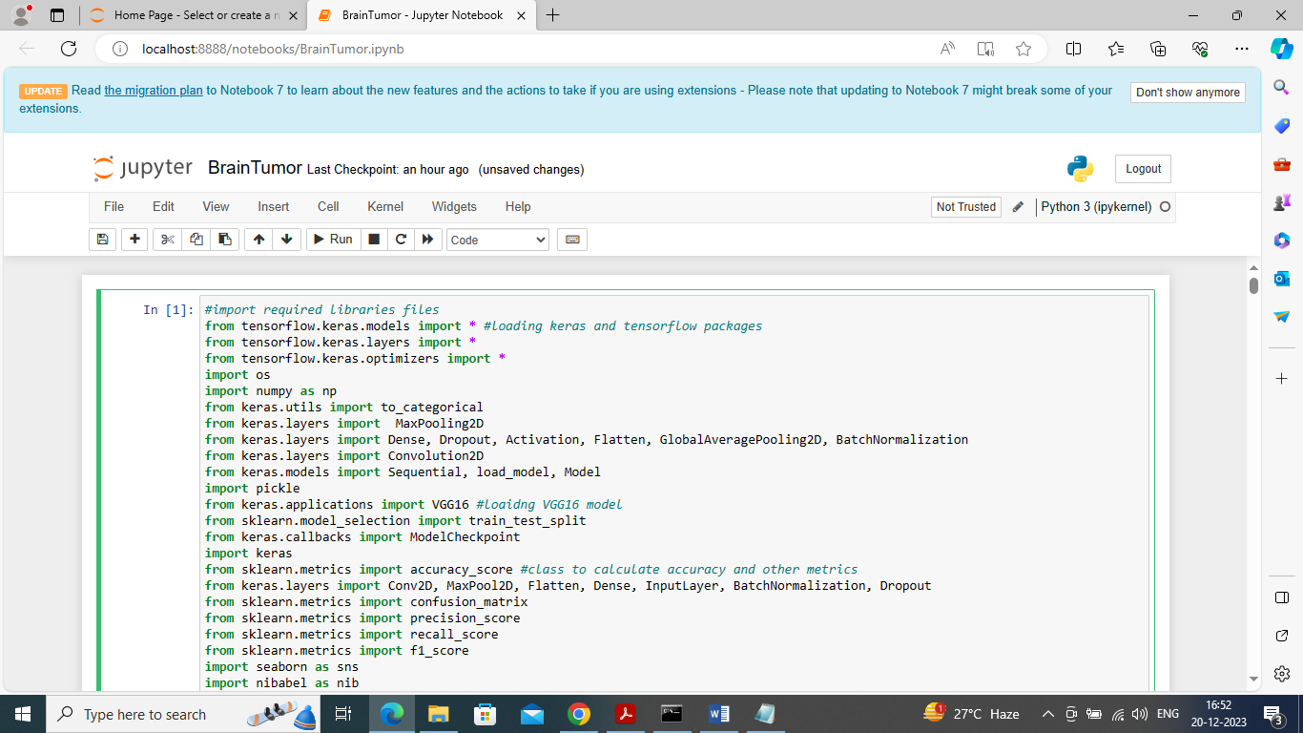**

**Fig.8. Importing python classes**

In above screen importing required classes and packages

**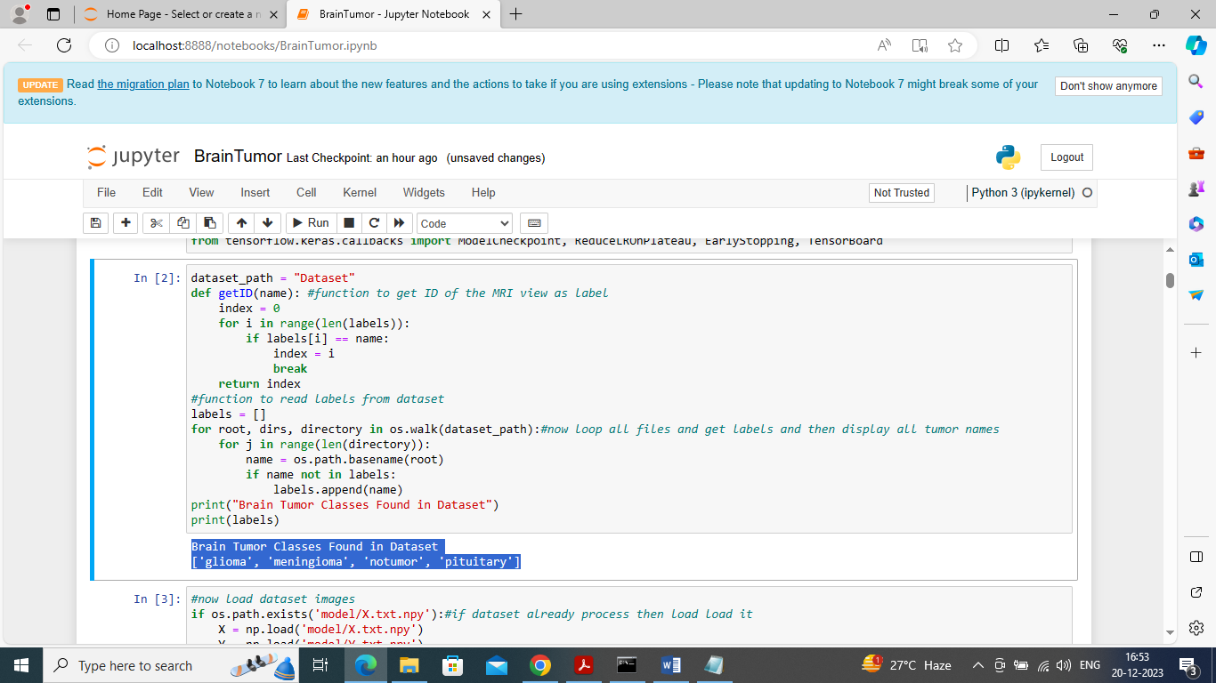**

**Fig.9 loading dataset**

In above screen loading dataset to identify different tumor or class labels found in dataset and all tumor names we can see in blue colour text

**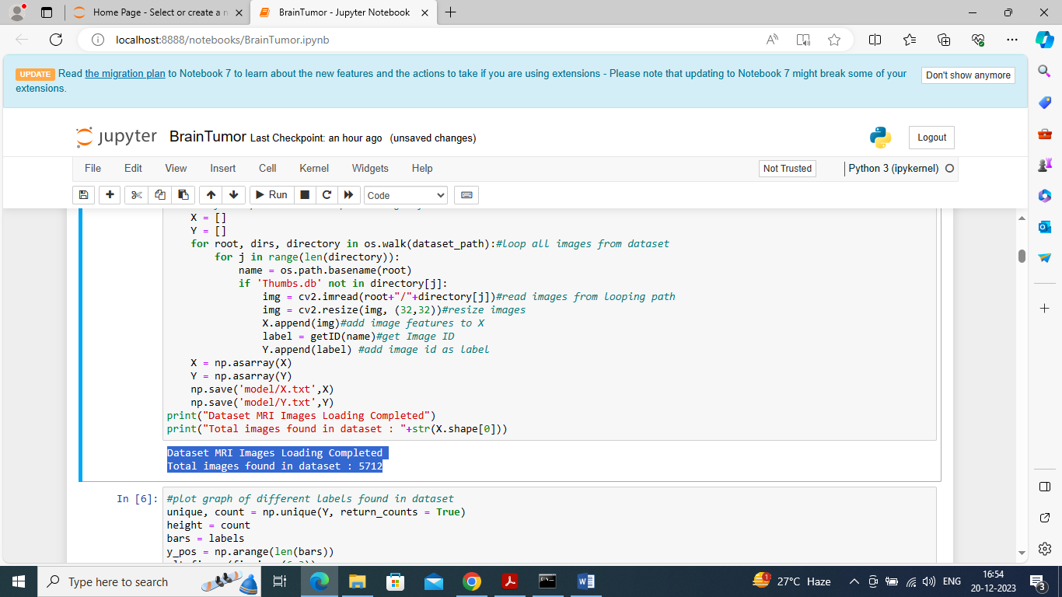**

**Fig.10 looping and reading all images**

In above screen looping and reading all images from dataset and then resizing all images to equal size and then adding to X and Y training arrays and then in blue colour text can see total number of images loaded

**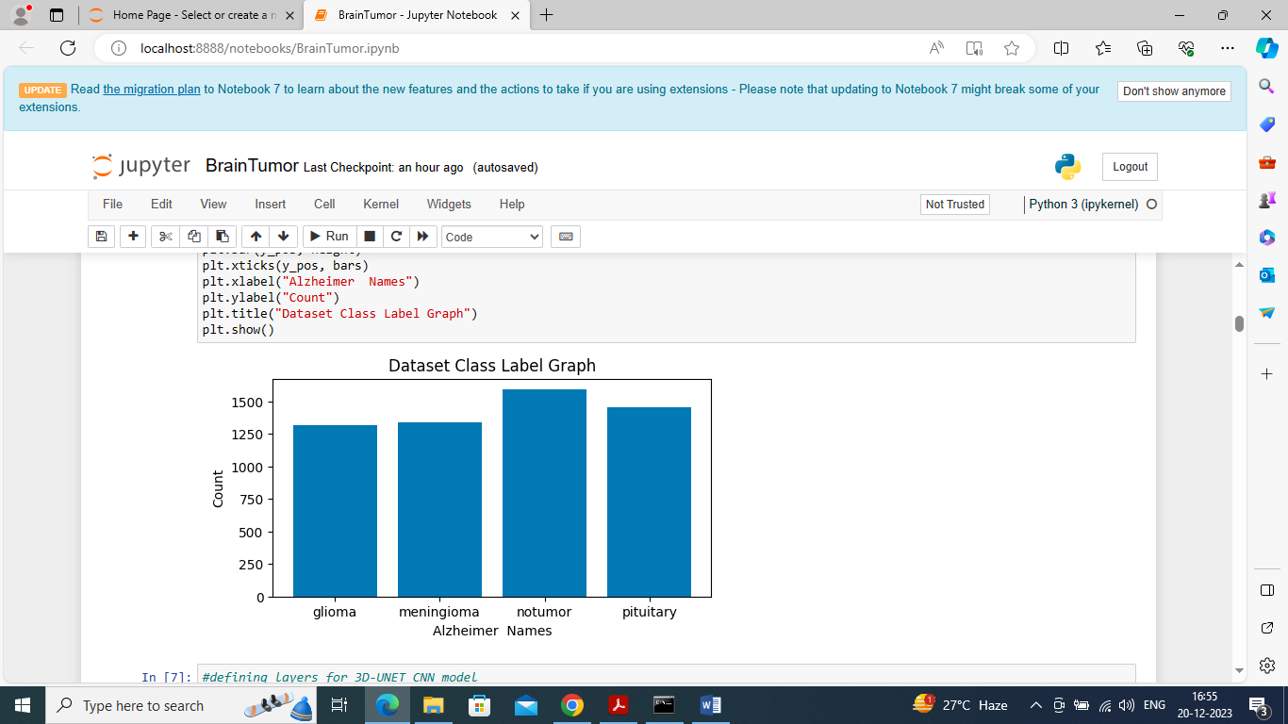**

**Fig.11 Graphical representation**

In abo ve graph x-axis represents tumor class label and y-axis represents number of images found in that class label

**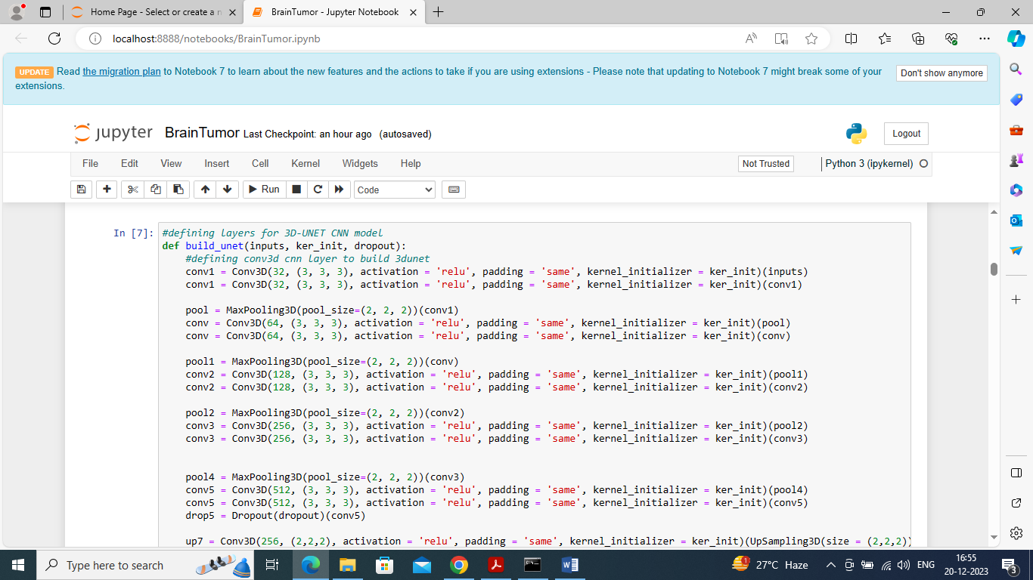**

**Fig.12 defining 3D-UNET model**

In above screen defining 3D-UNET model by using CONV3D layer

**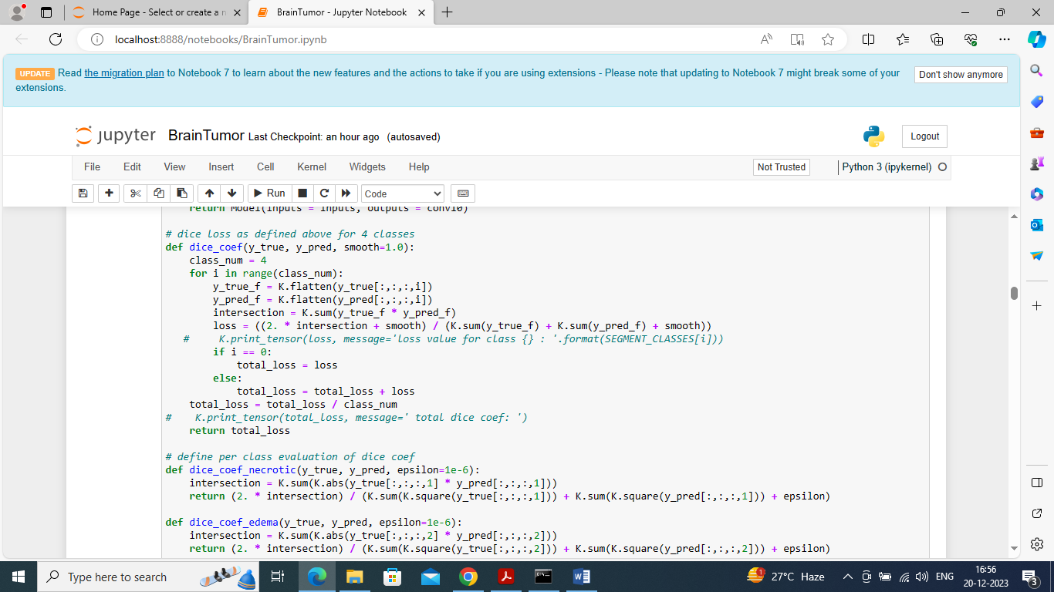**

**Fig.13 defining dice score function**

In above screen defining dice score function to train UNET with dice score

**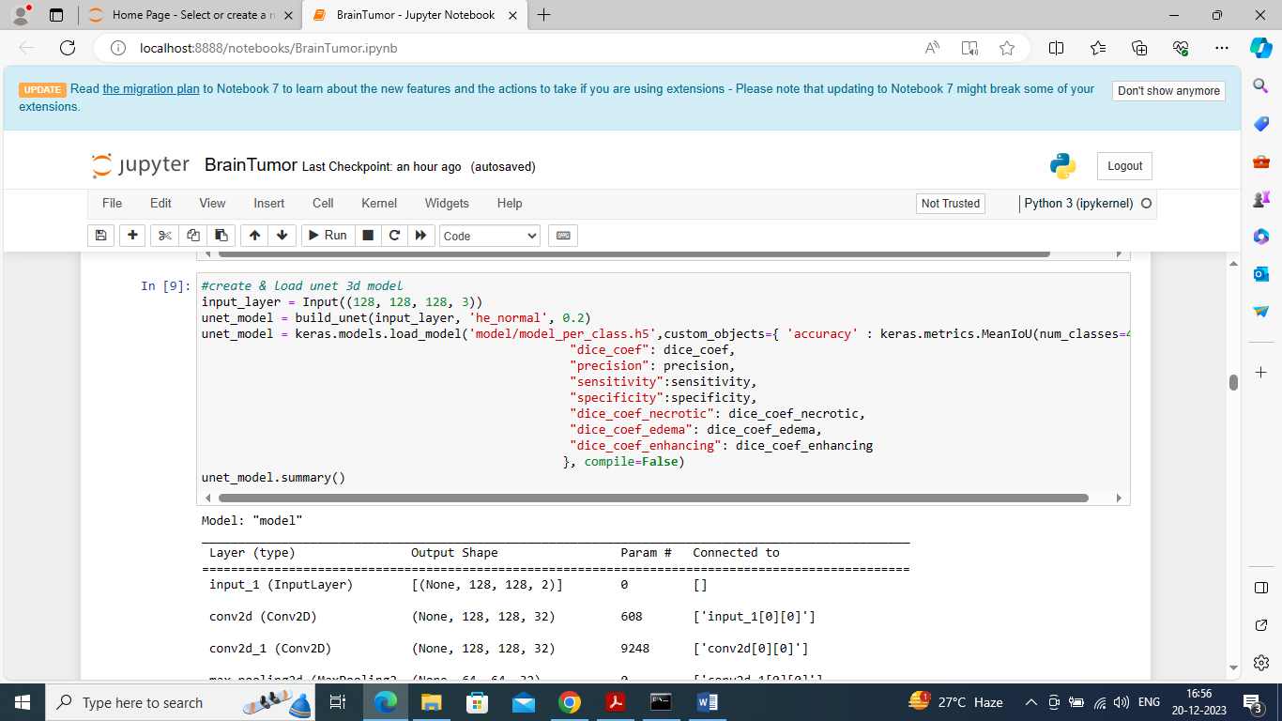**

**Fig.14 creating and loading 3DUNET**

In above screen creating and loading 3DUNET model with all metrics like Precision, dice and many more and then displaying loaded model details

**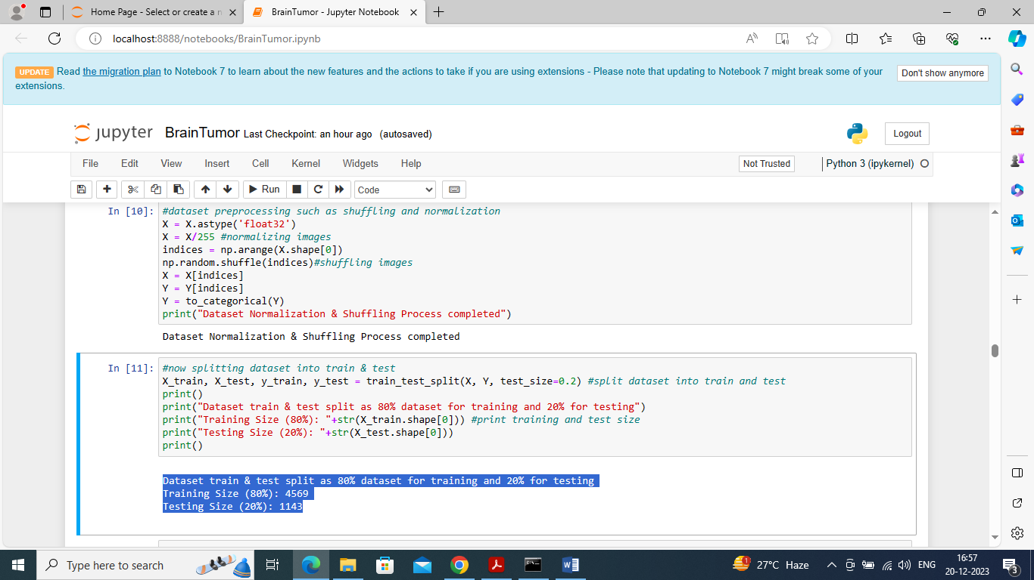**

**Fig.15 defining code to shuffle, normalize images**

In above screen defining code to shuffle, normalize images and then split images into train and test where application using 80% images for training and 20% for testing

**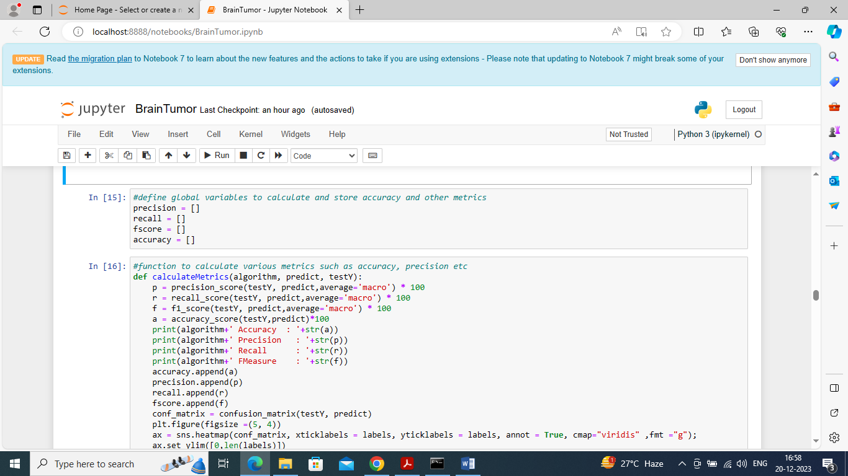**

**Fig.16 defining function to calculate accuracy**

In above screen defining function to calculate accuracy and other metrics

**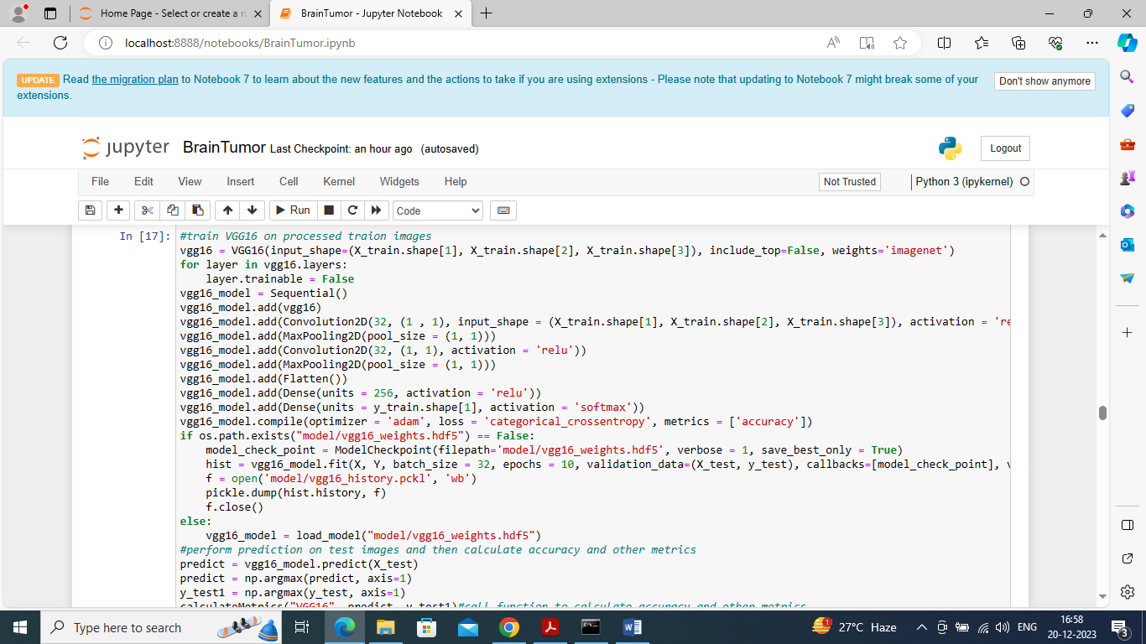**

**Fig.17 training VGG16 existing algorithm**

In above screen training VGG16 existing algorithm and after executing above model on 20% test images will get below output

**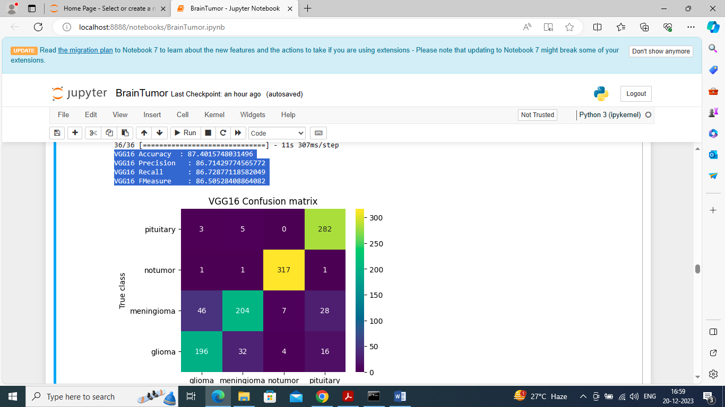**

**Fig.18 VGG16 Confusion matrix**

In above screen VGG16 got 87% accuracy and can see other metrics like precision, recall etc. In confusion matrix graph x-axis represents Predicted Labels and y-axis represents true labels and all boxes count if diagnol with different colour represents Correct Prediction count and remaining blue boxes represents incorrect prediction count which are very few

**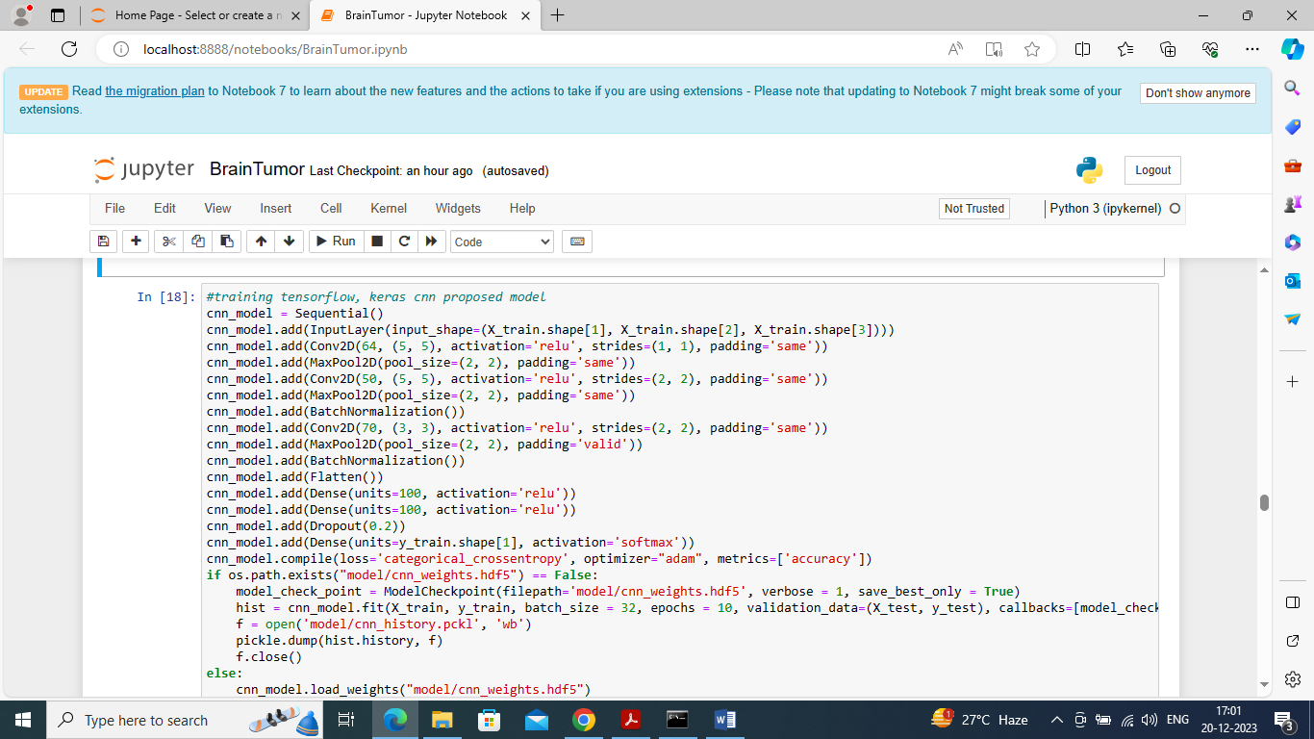**

**Fig.19 defining propose 16 layers CNN model**

In above screen defining propose 16 layers CNN model and in above code each line will represents one layer and after executing above model will get below output

**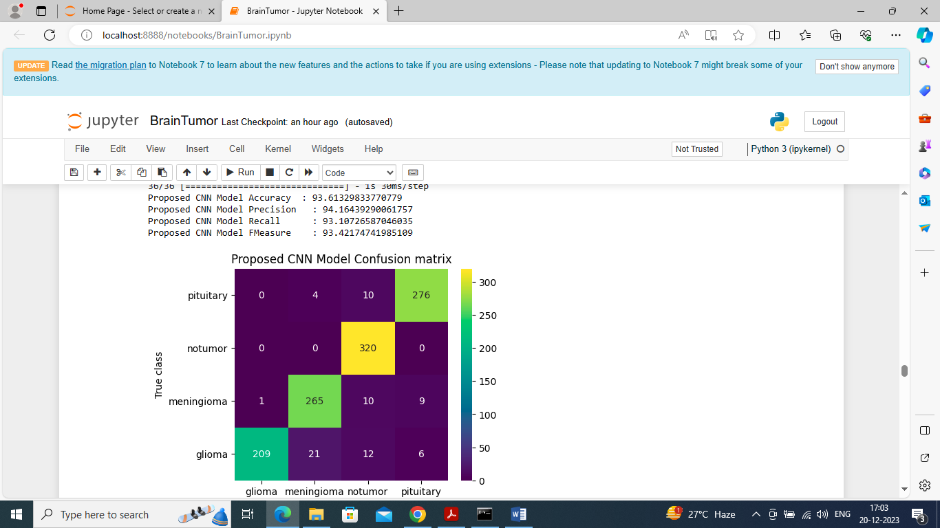**

**Fig.20. Proposed CNN Mode confusion matrix**

In above screen propose CNN model got 93% accuracy and can see other results also

**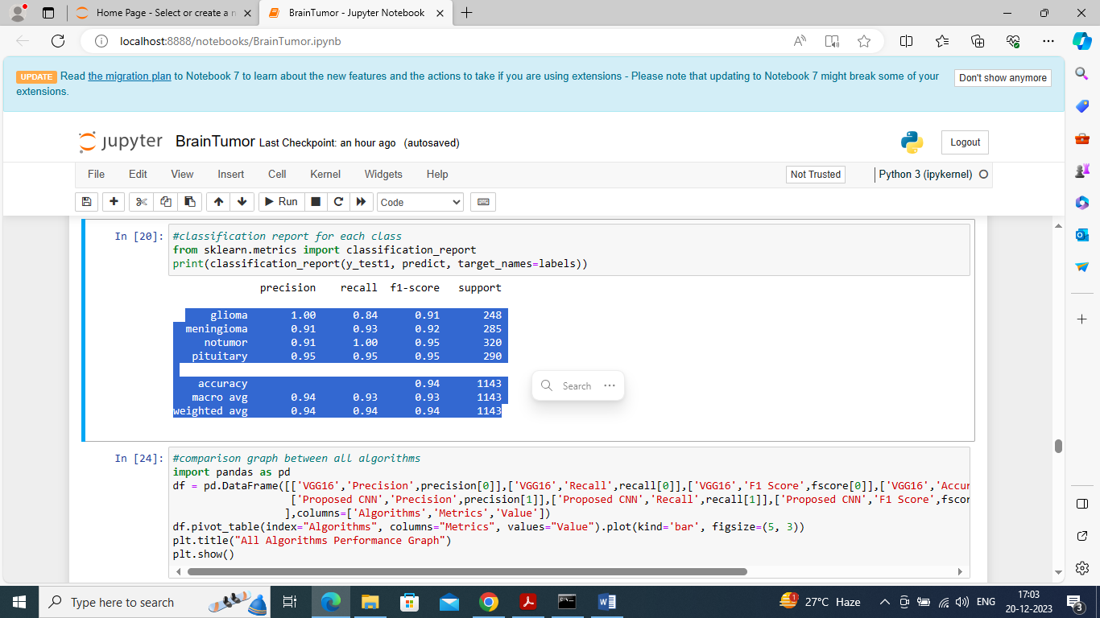**

**Fig.21 defining propose 16 layers CNN model**

In above screen can see classification report output for each tumor class

**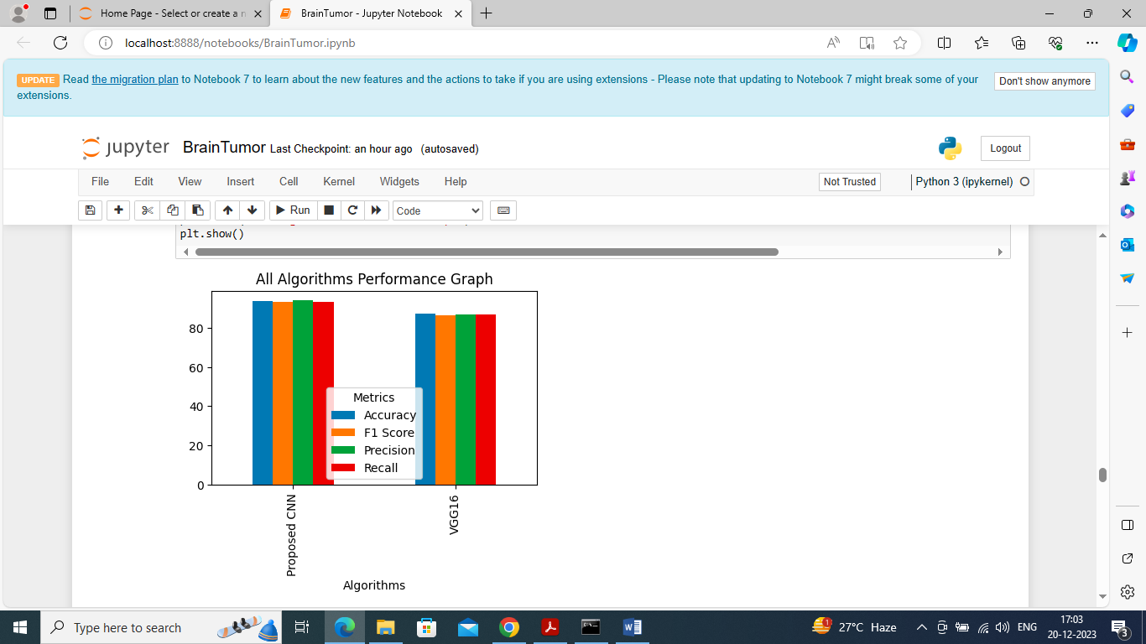**

**Fig.22 comparison graph**

In above screen displaying comparison graph between propose and VGG16 and in above graph x-axis represents algorithm names and y-axis represents accuracy and other metrics in different colour bars and in above graph in both algorithms propose got high results

**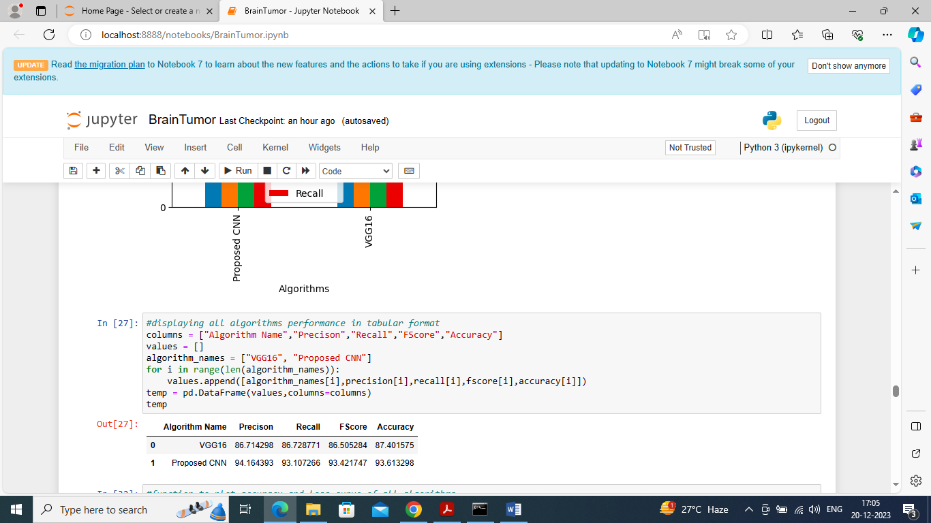**

**Fig.23. algorithm results in tabular format**

In above screen can see both algorithm results in tabular format

**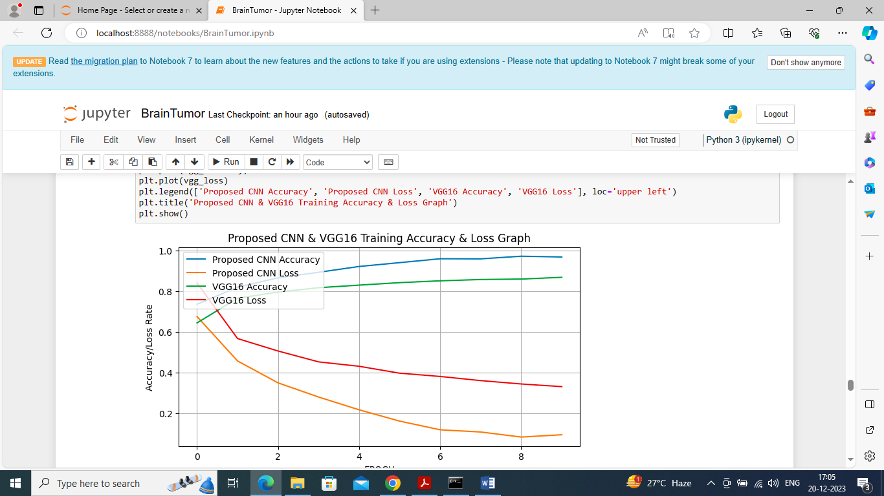**

**Fig.24 Proposed CNN and VGG16 training accuracy and loss graph**

In above graph displaying VGG and propose CNN training and loss graph and in graph x-axis represents training epochs and y-axis represents accuracy/loss values and then blue line is for propose CNN accuracy and green line for VGG16 accuracy and red line for VGG16 loss and orange line for propose CNN loss. In above graph we can see with each increasing epoch accuracy got increase and loss got decrease for both algorithms but propose got high training accuracy and less loss.

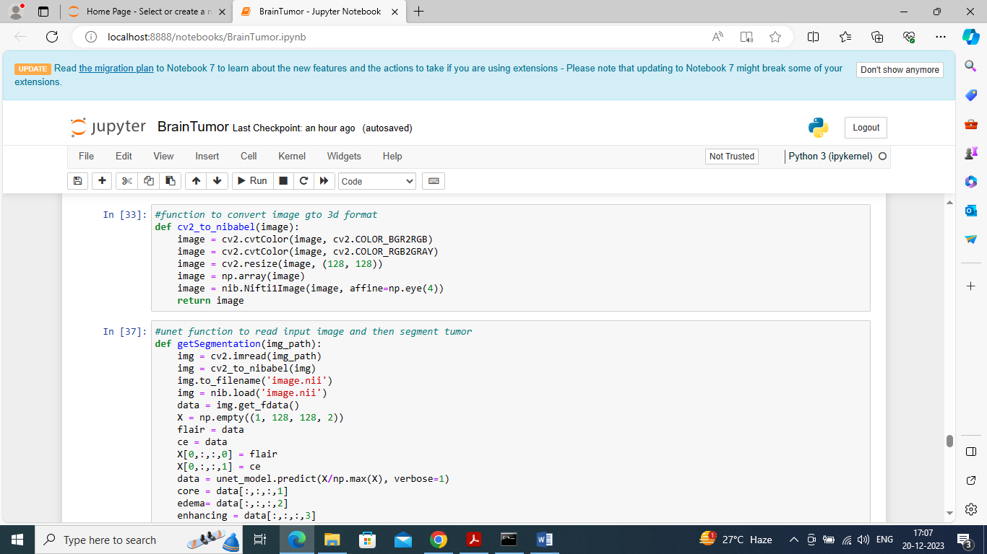

**Fig.25 segment test image using UNET**

In above screen defining function to segment test image using UNET

**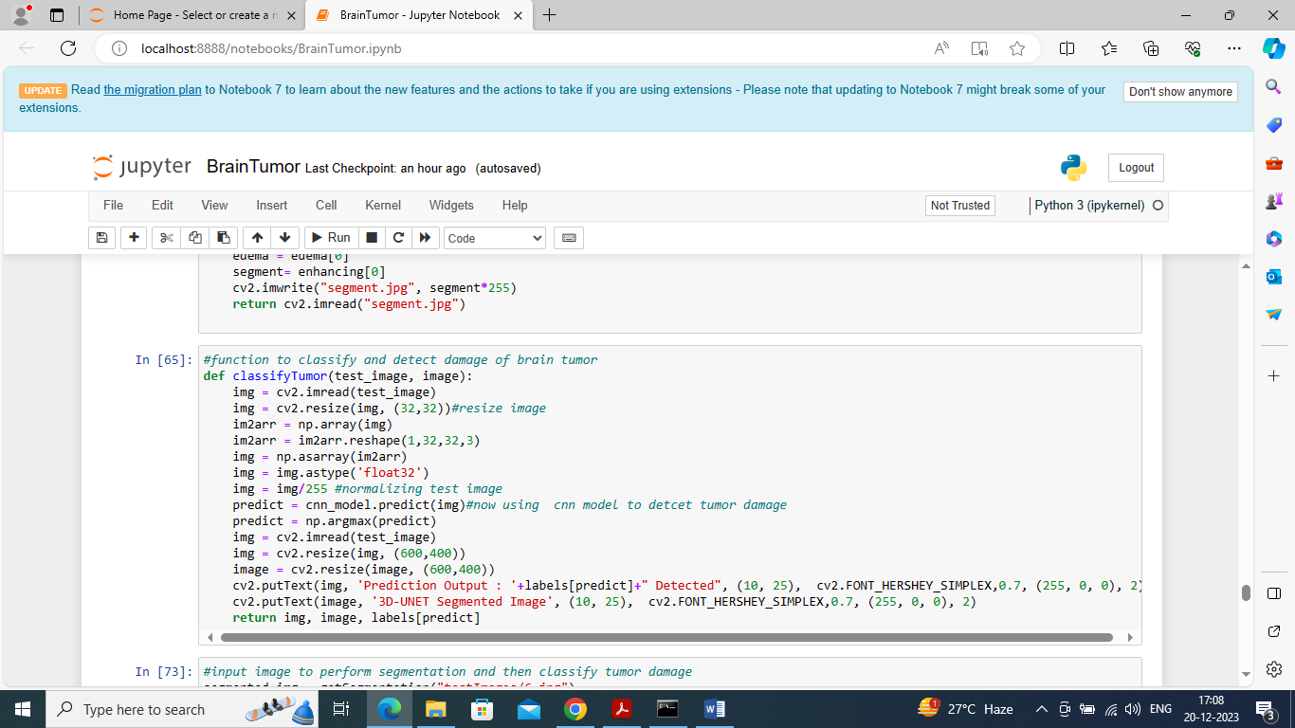**

**Fig.26 classify tumor or predict damage**

In above screen defining function to classify tumor or predict damage

**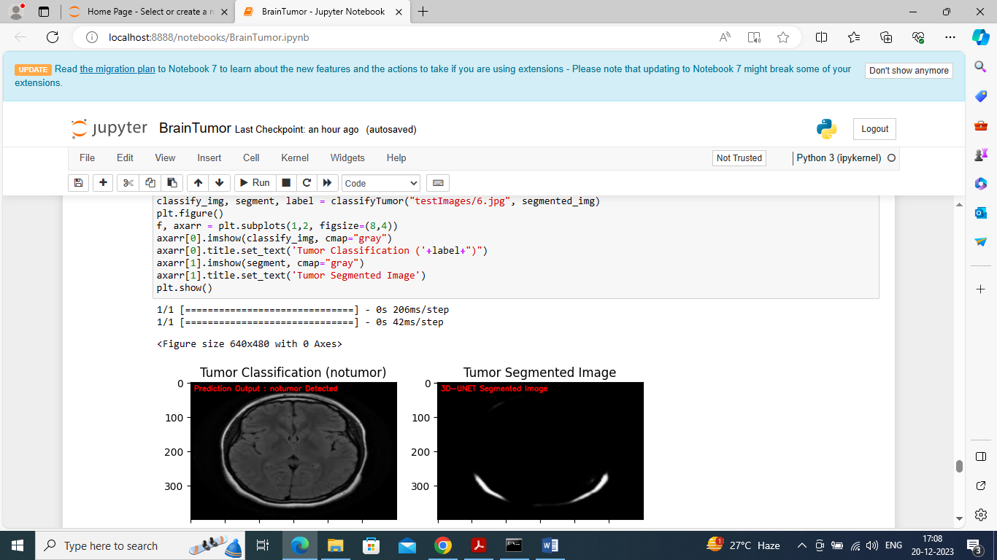**

**Fig.27 test image for segmentation**

In above screen giving test image for segmentation and in output given image predicted as ‘NO Tumor’ and in segmented image also we cannot see any tumor region so brain is normal. Predicted output you can see in red colour text or in image title

**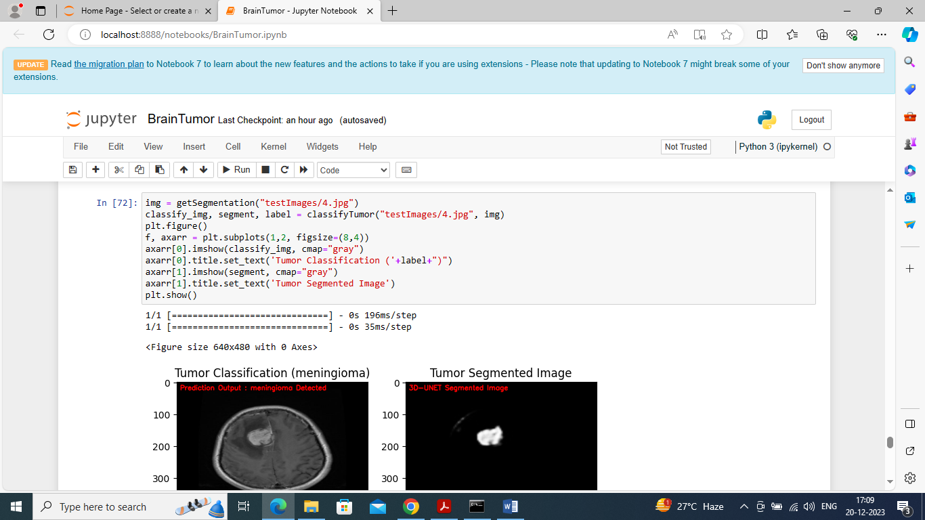**

**Fig.28‘meningioma’ tumor is predicted**

In above screen ‘meningioma’ tumor is predicted and in segmented output we can see that tumor clearly. Segmented image showing in second part of image

**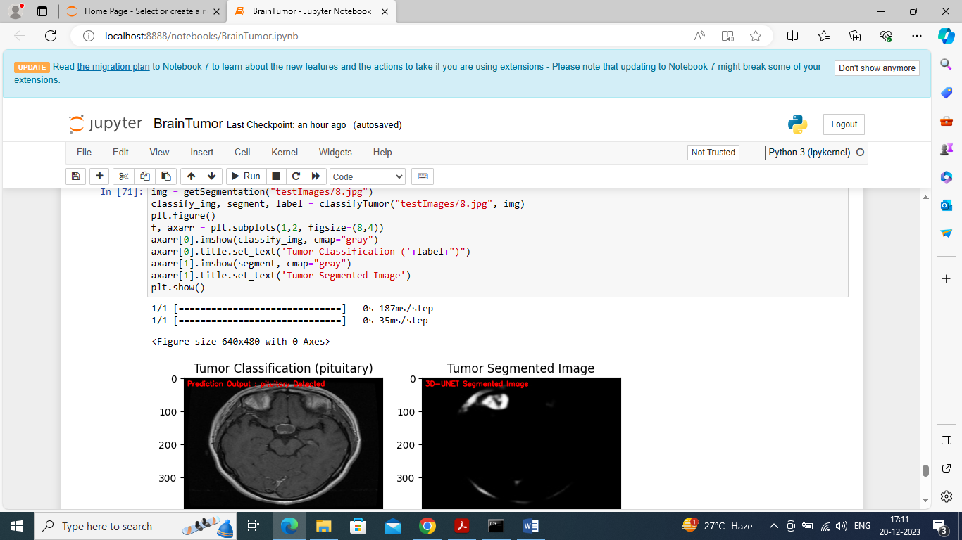**

**Fig.29 pituitary’ tumor detected**

In above screen ‘pituitary’ tumor detected and in segmented second image we can see tumor clearly

**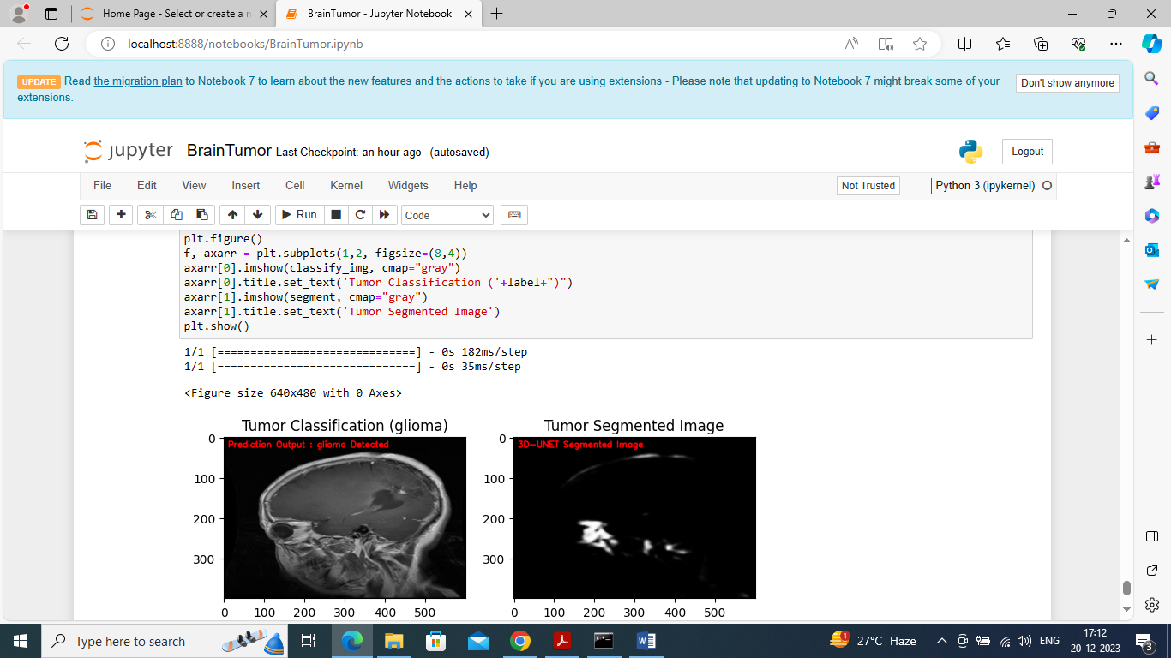**

**Fig.30‘glioma’ tumor detected**

In above screen ‘glioma’ tumor detected and in segmented second image we can see tumor part

**CHAPTER 6**

**CONCLUSION**

In this study, segmentation and detection of brain tumor have been done using deep neural networks. In the present study, the MRI image dataset is used to train the neural network, and then soft dice loss is used to detect losses in the segmented model. Later, the model is trained, rectifying those losses and giving the segmented image as output. Initially, the 3D MRI model is divided into 3D sub-models to pass through the segmentation model. There are two datasets used for the CNN models. Every dataset is taken from different patients from different parts of the world to conquer the problem of generalization. Secondly, the CNN model is implemented in particular for the three most popular kinds of brain tumor, i.e., glioma, meningioma, and pituitary, to be classified immediately without involving the use of area-based pre-processing procedures. The results obtained establish the efficacy of the proposed work when compared to the models already proposed in the literature.

**REFERENCES**

[1] G. Alain and Y. Bengio, "What regularized auto-encoders gain from the data making allotment," J. Mach. Learn. Res., vol. 15, no. 1, pp. 3563–3593, 2014.

[2] M. R. Avendi, A. Kheradvar, and H. Jafarkhani, "A solidified significant learning and deformable-model approach to manage totally customized division of the left ventricle in heart MRI," MedIA Image Anal., vol. 30, pp. 108–119, May 2016.

[3] M. R. Avendi, A. Kheradvar, and H. Jafarkhani, "Modified division of the right ventricle from heart MRI using a learning-based system," in Magnetic Resonance in Medicine. New York, NY, USA: Wiley, Feb. 2017, doi: 10.1002/mrm.26631.

[4] W. Bai et al., "A bi-ventricular cardiovascular guide book worked from 1000+ significant standards MR pictures of sound subjects and an examination of shape and development," MedIA Image Anal., vol. 26, no. 1, pp. 133–145, 2015.

[5] W. Bai et al., "A probabilistic fix based name blend model for multiatlas division with selection refinement: Application to cardiovascular MR pictures," IEEE Trans. Medication. Picture. vol. 32, no. 7, pp. 1302–1315, Jul. 2013.

[6] D. Barbosa et al., "Speedy and totally customized 3-D echocardiographic division using B-spline unequivocal unique surfaces: Feasibility study and endorsement in a clinical setting," Ultrasound Med. Biol., vol. 39, no. 1, pp. 89–101, 2013.

[7] A. BenTaieb and G. Hamarneh, "Topology careful totally convolutional frameworks for histology organ division," in Proc. Int. Conf. MICCAI, 2016, pp. 460–468.

[8] O. Bernard et al., "Standardized evaluation system for left ventricular division computations in 3D echocardiography," IEEE Trans. Prescriptions. Picture., vol. 35, no. 4, pp. 967–977, Apr. 2016.

[9] F. Chen, H. Yu, R. Hu, and X. Zeng, "Significant learning shape priors for object division," in Proc. IEEE CVPR, Jun. 2013, pp. 1870–1877.

[10] H. Chen, X. Qi, L. Yu, Q. Dou, J. Qin, and P.- A. Heng, "DCAN: Deep structure careful frameworks for object model division from histology pictures," MedIA Image Anal., vol. 36, pp. 135–146, Feb. 2017.

[11] H. Chen, Y. Zheng, J.- H. Park, P.- A. Heng, and S. K. Zhou, "Iterative multi-territory regularized significant learning for anatomical structure acknowledgment and division from ultrasound pictures," in Proc. Int. Conf. MICCAI, 2016, pp. 487–495.

[12] Ö. Çiçek, A. Abdulkadir, S. S. Lienkamp, T. Brox, and O. Ronneberger, "3D U-Net: Learning thick volumetric division from lacking remark," in Proc. MICCAI, 2016, pp. 424–432.

[13] T. F. Cootes and C. J. Taylor, "Joining point movement models with shape models reliant on constrained segment assessment," Image Vis. Comput., vol. 13, no. 5, pp. 403–409, 1995.

14] C. Davatzikos, X. Tao, and D. Shen, "Different leveled dynamic shape models, using the wavelet change," IEEE Trans. Meds. Picture., vol. 22, no. 3, pp. 414–423, Mar. 2003.

[15] A. de Marvao et al., "People based examinations of myocardial hypertrophy: High objectives cardiovascular alluring resonation map books improve quantifiable power," J. Cardiovascular Magn. Reson.vol. 16, no. 1, p. 16, 2014.

[16] C. Dong, C. C. Loy, and X. Tang, "Enlivening the super-objectives convolutional neural framework," in Proc. ECCV, 2016, pp. 391–407.

[17] S. Eslami and C. Williams, "A generative model for parts-based thing division," in Proc. NIPS, 2012, pp. 100–107.

[18] S. M. A. Eslami, N. Heess, and J. Winn, "The shape Boltzmann machine: A strong model of thing shape," in Proc. IEEE Conf. Comput. Vis. Model Recognit., Jun. 2012, pp. 406–413.

[19] R. Girdhar, D. F. Fouhey, M. Rodriguez, and A. Gupta, "Learning an envisioned and generative vector depiction for objects," in Proc. ECCV, 2016, pp. 484–499.

[20] H. Greenspan, "Super-objectives in clinical imaging," Compute. J., vol. 52, no. 1, pp. 43–63, 2009.

[21] J. Johnson, A. Alahi, and L. Fei-Fei, "Perceptual disasters for consistent style move and super-objectives," in Proc. ECCV, 2016, pp. 694–711.

[22] K. Kamnitsas et al., "Gainful multi-scale 3D CNN with totally related CRF for precise brain sore division," Media Image Anal., vol. 36, pp. 61–78, Feb. 2017.

[23] T. D. Karamitsos, J. M. Francis, S. Myerson, J. B. Selvanayagam, and S. Neubauer, "The activity of cardiovascular appealing resonation imaging in cardiovascular breakdown," J. Amer. School Cardiol., vol. 54, no. 15, pp. 1407–1424, 2009.

[24] J. Lafferty, A. McCallum, and F. C. N. Pereira, "Prohibitive unpredictable fields: Probabilistic models for separating and naming progression data," in Proc. ICML, vol. 1. 2001, pp. 282–289.

[25] R. M. Lang et al., "EAE/ASE proposition for picture making sure about and show using three-dimensional echocardiography," J. Amer. Soc. Echocardiogr., vol. 25, no. 1, pp. 1–46, 2012.

[26] C. Ledig et al., (Sep. 2016). "Photo handy single picture super objectives using a generative poorly arranged framework."[Online]. Available: <https://arxiv.org/abs/1609.04802>

[27] K. Li, B. Hariharan, and J. Malik, "Iterative event division," in Proc. CVPR, 2016, pp. 3659–3667.

[28] G. Litjens et al., (2017). "An audit on significant learning in clinical picture assessment."[Online]. Open: <https://arxiv.org/abs/1702.05747>

[29] J. Long, E. Shelhamer, and T. Darrell, "Totally convolutional frameworks for semantic division," in Proc. CVPR, 2015, pp. 3431–3440.

[30] P. Luc, C. Couprie, S. Chintala, and J. Verbeek. (Dec. 2016). "Semantic division using poorly arranged frameworks." [Online]. Open: https://arXiv preprint arXiv: 1611.08408

[31] J. Masci, U. Meier, D. Cire¸ san, and J. Schmidhuber, "Stacked convolutional auto-encoders for dynamic segment extraction," in Proc. Int. Conf. Workmanship if. Neural Netw. 2011, pp. 52–59.

[32] M. S. Nosrati and G. Hamarneh. (2016). "Merging prior data in clinical picture division: An examination." [Online]. Open: <https://arxiv.org/abs/1607.01092>

[33] O. Oktay et al., "Isolated decision forests for definite anatomical achievement limitation in heart pictures," IEEE Trans. Drugs. Picture., vol. 36, no. 1, pp. 332–342, Jan. 2017.

**APPENDIX**

**PYTHON**

**1.1 Introduction**

\* One of the most popular languages is Python. Guido van Rossum released this language in 1991. Python is available on the Mac, Windows, and Raspberry Pi operating systems. The syntax of Python is simple and identical to that of English. When compared to Python, it was seen that the other language requires a few extra lines.

\*It is an interpreter-based language because code may be run line by line after it has been written. This implies that rapid prototyping is possible across all platforms. Python is a big language with a free, binary-distributed interpreter standard library.

\* It is inferior to maintenance that is conducted and is straightforward to learn. It is an object-oriented, interpreted programming language. It supports several different programming paradigms in addition to object-oriented programming, including functional and procedural programming.

\* It supports several different programming paradigms in addition to object-oriented programming, including practical and procedural programming. Python is mighty while maintaining a relatively straightforward syntax. Classes, highly dynamic data types, modules, and exceptions are covered. Python can also be utilised by programmes that require programmable interfaces as an external language.

Here are some key features and characteristics of Python:

* Readability: Python emphasizes code readability with its clean and intuitive syntax. It uses indentation and whitespace to structure code blocks, making it easy to understand and maintain.
* Easy to Learn: Python's simplicity and readability make it an excellent choice for beginners. Its straightforward syntax and extensive documentation make it accessible for newcomers to programming.
* Interpreted Language: Python is an interpreted language, meaning that it doesn't need to be compiled before running. The Python interpreter reads and executes the code directly, making the development process faster and more interactive.
* Cross-platform Compatibility: Python is available for major operating systems like Windows, macOS, and Linux. This cross-platform compatibility allows developers to write code once and run it on different platforms without modifications.
* Large Standard Library: Python comes with a vast standard library that provides ready-to-use modules and functions for various tasks. It covers areas such as file I/O, networking, regular expressions, databases, and more, saving developers time and effort.
* Extensible and Modular: Python supports modular programming, enabling developers to organize code into reusable modules and packages. Additionally, Python allows integrating modules written in other languages, such as C or C++, providing flexibility and performance optimizations.
* Wide Range of Libraries and Frameworks: Python has a vibrant ecosystem with numerous third-party libraries and frameworks. These libraries, such as NumPy, pandas, TensorFlow, and Django, extend Python's capabilities for specific domains, making it a powerful tool for diverse applications.
* Object-Oriented: Python supports object-oriented programming (OOP) principles, allowing developers to create and work with classes and objects. OOP provides a structured approach to code organization, promoting code reuse and modularity.
* Dynamic Typing: Python is dynamically typed, meaning variable types are determined at runtime. Developers do not need to declare variable types explicitly, which enhances flexibility and simplifies code writing.

**1.2 Installation**

To install Python on your computer, follow these basic steps:

* Step 1: Visit the Python website Go to the official Python website at <https://www.python.org/>.
* Step 2: Select the operating system Choose the appropriate installer for your operating system. Python supports Windows, macOS, and various Linux distributions. Make sure to select the correct version that matches your operating system.
* Step 3: Check which version of Python is installed; if the 3.7.0 version is not there, uninstall it through the control panel and
* Step 4: Install Python 3.7.0 using Cmd.
* Step 5: Install the all libraries that required to run the project
* Step 6: Run

**1.3 Python Features:**

1. **Easy:** Because Python is a more accessible and straightforward language, Python programming is easier to learn.
2. **Interpreted language:** Python is an interpreted language, therefore it can be used to examine the code line by line and provide results.
3. **Open Source:** Python is a free online programming language since it is open-source.
4. **Portable:** Python is portable because the same code may be used on several computer standard
5. **libraries:** Python offers a sizable library that we may utilize to create applications quickly.
6. **GUI:** It stands for GUI (Graphical User Interface)
7. **Dynamical typed:** Python is a dynamically typed language, therefore the type of the value will be determined at runtime.

**1.4 Python GUI (Tkinter)**

* Python provides a wide range of options for GUI development (Graphical User Interfaces).
* Tkinter, the most widely used GUI technique, is used for all of them.
* The Tk GUI toolkit offered by Python is used with the conventional Python interface.
* Tkinter is the easiest and quickest way to write Python GUI programs.
* Using Tkinter, creating a GUI is simple.
* A part of Python's built-in library is Tkinter. The GUI programs were created.
* Python and Tkinter together give a straightforward and quick way. The Tk GUI toolkit's object-oriented user interface is called Tkinter.

Making a GUI application is easy using Tkinter. Following are the steps:

1) Install the Tkinter module in place.

2) The GUI applicatioMakeske the primary window

3) Include one or more of the widgets mentioned above in the GUI application.

4) Set up the main event loop such that it reacts to each user-initiated event.

Although Tkinter is the only GUI framework included in the Python standard library, Python includes a GUI framework. The default library for Python is called Tkinter. Tk is a scripting language often used in designing, testing, and developing GUIs. Tk is a free, open-source widget toolkit that may be used to build GUI applications in a wide range of computer languages.

**1.5 Python IDLE**

* Python IDLE offers a full-fledged file editor, which gives you the ability to write and execute Python programs from within this program. The built-in file editor also includes several features, like code completion and automatic indentation, that will speed up your coding workflow.
* Guido Van Rossum named Python after the British comedy group Monty Python while the name IDLE was chosen to pay tribute to Eric Idle, who was one of the Monty Python's founding members. IDLE comes bundled with the default implementation of the Python language since the 01.5. 2b1 release
* IDLE is used to execute statements similar to Python Shell. IDLE is used to create, modify, and execute Python code. IDLE provides a fully-featured text editor to write Python scripts and provides features like syntax highlighting, auto-completion, and smart indent.
* IDLE has two modes: interactive and script. We wrote our first program, “Hello, World!” in interactive mode. Interactive mode immediately returns the results of commands you enter into the shell. In script mode, you will write a script and then run it.
* The IDE Python IDLE is a good place to start as it helps you become familiar with the way Python works and understand its syntax. This IDE is good to start programming in Python due to its great debugger, but once you are fluent and start developing projects it is necessary to jump to another, more complete IDE.
* Python IDLE (Integrated Development and Learning Environment) is an interactive development environment included with the Python programming language. It provides a convenient way to write, execute, and debug Python code.

When you install Python, IDLE is typically installed along with it. To open IDLE, you can follow these steps:

* Open the command prompt (Windows) or terminal (macOS/Linux).
* Type "idle" and press Enter. Alternatively, you can specify the version with "idle3" or "idle2" for Python 3 or Python 2, respectively.
* Once IDLE is launched, you will see the Python shell, which is an interactive environment where you can type and execute Python code directly.

Here are some features and functionalities provided by Python IDLE:

* Editor: IDLE includes a text editor where you can write your Python code. It offers syntax highlighting, automatic indentation, and code completion to enhance your coding experience.
* Interactive Shell: The Python shell in IDLE allows you to execute Python code interactively. You can type commands, statements, or function calls directly in the shell, and Python will execute them immediately.
* Debugging: IDLE provides basic debugging capabilities to help you find and fix errors in your code. You can set breakpoints, step through code, inspect variables, and track the program's execution.
* Python Help: IDLE provides access to the Python documentation and built-in help. You can access the help menu to find information about Python modules, functions, classes, and more.
* Script Execution: In addition to the interactive shell, IDLE allows you to run Python scripts stored in files. You can write your code in the editor and execute it as a script to see the output or interact with the program.
* Customization: IDLE can be customized to suit your preferences. You can modify settings related to syntax highlighting, indentation, fonts, and more.
* Python IDLE serves as a beginner-friendly development environment and learning tool. It is suitable for writing small scripts, testing code snippets, experimenting with Python features, and learning the language's basics. However, for more advanced development projects, you may consider using other code editors or integrated development environments (IDEs) that provide additional features and better project management capabilities.

**1.6 Libraries**

In Python, libraries (also referred to as modules or packages) are collections of pre-written code that provide additional functionality and tools to extend the capabilities of the Python language. Libraries contain reusable code that developers can leverage to perform specific tasks without having to write everything from scratch.

Python libraries are designed to solve common problems, such as handling data, performing mathematical operations, interacting with databases, working with files, implementing networking protocols, creating graphical user interfaces (GUIs), and much more. They provide ready-to-use functions, classes, and methods that simplify complex operations and save development time.

**Libraries in Python offer various advantages:**

* Code Reusability:
* Efficiency:
* Collaboration
* Domain-Specific Functionality
* To use a Python library, you need to install it first.

There are some libraries following:

* **Pandas:**

Pandas are a Python computer language library for data analysis and manipulation. It offers a specific operation and data format for handling time series and numerical tables. It differs significantly from the release3-clause of the BSD license. It is a well-liked open-source of opinion that is utilized in machine learning and data analysis.

Pandas are a Python package providing fast, flexible, and expressive data structures designed to make working with “relational” or “labeled” data both easy and intuitive. It aims to be the fundamental high-level building block for doing practical, real-world data analysis in Python. Pandas are a Python library used for working with data sets.

* It has functions for analysing, cleaning, exploring, and manipulating data.
* The name "Pandas" has a reference to both "Panel Data", and "Python Data Analysis" and was created by Wes McKinney in 2008.
* Pandas allow us to analyse big data and make conclusions based on statistical theories.
* Pandas can clean messy data sets, and make them readable and relevant.

Relevant data is very important in data science. Pandas are a Python library for data analysis. Started by Wes McKinney in 2008 out of a need for a powerful and flexible quantitative analysis tool, pandas have grown into one of the most popular Python libraries. It has an extremely active community of contributors. The name is derived from the term "panel data", an econometrics term for data sets that include observations over multiple time periods for the same individuals. Its name is a play on the phrase "Python data analysis" itself.

* **NumPy:**

The NumPy Python library for multi-dimensional, big-scale matrices adds a huge number of high-level mathematical functions. It is possible to modify NumPy by utilizing a Python library. Along with line, algebra, and the Fourier transform operations, it also contains several matrices-related functions.

NumPy can be used to perform a wide variety of mathematical operations on arrays. It adds powerful data structures to Python that guarantee efficient calculations with arrays and matrices and it supplies an enormous library of high-level mathematical functions that operate on these arrays and matrices.

* NumPy is a Python library used for working with arrays.
* It also has functions for working in domain of linear algebra, Fourier transform, and matrices.
* NumPy was created in 2005 by Travis Oliphant. It is an open source project and you can use it freely.
* NumPy stands for Numerical Python.
* In Python we have lists that serve the purpose of arrays, but they are slow to process.
* NumPy aims to provide an array object that is up to 50x faster than traditional Python lists.
* The array object in NumPy is called ndarray, it provides a lot of supporting functions that make working with ndarray very easy.
* Arrays are very frequently used in data science, where speed and resources are very important.
* **Matplotlib:**

It is a multi-platform, array-based data visualization framework built to interact with the whole SciPy stack. MATLAB is proposed as an open-source alternative. Matplotlib is a Python extension and a cross-platform toolkit for graphical plotting and visualization.

Matplotlib is a popular Python library for creating static, animated, and interactive visualizations. It provides a flexible and comprehensive set of tools for generating plots, charts, histograms, scatter plots, and more. Matplotlib is widely used in various fields, including data analysis, scientific research, and data visualization.

Here are some key features and functionalities of the Matplotlib library:

* Plotting Functions
* Customization Options
* Multiple Interfaces
* Integration with NumPy and pandas
* Subplots and Figures:
* Saving and Exporting
* **Scikit-learn:**

The most stable and practical machine learning library for Python is scikit-learn. Regression, dimensionality reduction, classification, and clustering are just a few of the helpful tools it provides through the Python interface for statistical modeling and machine learning. It is an essential part of the Python machine learning toolbox used by JP Morgan. It is frequently used in various machine learning applications, including classification and predictive analysis.

Scikit-learn (also referred to as sklearn) is a widely used open-source machine learning library for Python. It provides a comprehensive set of tools and algorithms for various machine learning tasks, including classification, regression, clustering, dimensionality reduction, model selection, and pre-processing.

Here are some key features and functionalities of the Scikit-learn library:

* Easy-to-Use Interface:
* Broad Range of Algorithms:
* Data Pre-processing and Feature Engineering:
* Model Evaluation and Validation:
* Integration with NumPy and pandas:
* Robust Documentation and Community Support:
* **Keras:**

\* Google's Keras is a cutting-edge deep learning API for creating neural networks. It is created in Python and is designed to simplify the development of neural networks. Additionally, it enables the use of various neural networks for computation. Deep learning models are developed and tested using the free and open-source Python software known as Keras.

Keras is a high-level deep learning library for Python. It is designed to provide a user-friendly and intuitive interface for building and training deep learning models. Keras acts as a front-end API, allowing developers to define and configure neural networks while leveraging the computational backend engines, such as Tensor Flow or Theano.

Here are some key features and functionalities of the Keras library:

* User-Friendly API
* Multi-backend Support
* Wide Range of Neural Network Architectures
* Pre-trained Models and Transfer Learning:
* Easy Model Training and Evaluation:
* GPU Support:
* **h5py:**

\* The h5py Python module offers an interface for the binary HDF5 data format. Thanks to p5py, the top can quickly halt the vast amount of numerical data and alter it using the NumPy library. It employs common syntax for Python, NumPy, and dictionary arrays.

h5py is a Python library that provides a simple and efficient interface for working with datasets and files in the Hierarchical Data Format 5 (HDF5) format. HDF5 is a versatile data format commonly used for storing and managing large volumes of numerical data.

Here are some key features and functionalities of the h5py library:

* + HDF5 File Access
  + Dataset Handling:
  + Group Organization:
  + Attributes:
  + Compatibility with NumPy
  + Performance
* **Tensor flow**

TensorFlow is a Python library for fast numerical computing created and released by Google. It is a foundation library that can be used to create Deep Learning models directly or by using wrapper libraries that simplify the process built on top of TensorFlow. TensorFlow is an end-to-end open source platform for machine learning. TensorFlow is a rich system for managing all aspects of a machine learning system; however, this class focuses on using a particular TensorFlow API to develop and train machine learning models.

TensorFlow is a popular open-source library for machine learning and deep learning. It provides a comprehensive set of tools, APIs, and computational resources for building and training various types of machine learning models, especially neural networks.

Here are some key features and functionalities of TensorFlow:

* Neural Network Framework:
* Computational Graphs
* Automatic Differentiation
* GPU and TPU Support
* Distributed Computing
* Deployment Capabilities
* **Tkinter**

Tkinter is an acronym for "Tk interface". Tk was developed as a GUI extension for the Tcl scripting language by John Ousterhout. The first release was in 1991. Tkinter is the de facto way in Python to create Graphical User interfaces (GUIs) and is included in all standard Python Distributions. In fact, it's the only framework built into the Python standard library.

Tkinter is a standard Python library used for creating graphical user interfaces (GUIs). It provides a set of modules and classes that allow you to develop interactive and visually appealing desktop applications.

Here are some key features and functionalities of Tkinter:

* Cross-Platform Compatibility
* Simple and Easy-to-Use
* Widgets and Layout Management
* Event-Driven Programming
* Customization and Styling
* Integration with Other Libraries
* **NLTK**

NLTK is a toolkit build for working with NLP in Python. It provides us various text processing libraries with a lot of test datasets. A variety of tasks can be performed using NLTK such as tokenizing, parse tree visualization, etc NLTK (Natural Language Toolkit) is the go-to API for NLP (Natural Language Processing) with Python. It is a really powerful tool to pre-process text data for further analysis like with ML models for instance. It helps convert text into numbers, which the model can then easily work with.

NLTK (Natural Language Toolkit) is a Python library widely used for working with human language data and implementing natural language processing (NLP) tasks. It provides a set of tools, corpora, and resources for tasks such as tokenization, stemming, tagging, parsing, sentiment analysis, and more.

Here are some key features and functionalities of NLTK:

* Text Processing
* Part-of-Speech Tagging
* Named Entity Recognition
* Chunking and Parsing
* Sentiment Analysis:
* WordNet Integration:
* **Scipy**

SciPy is a collection of mathematical algorithms and convenience functions built on the NumPy extension of Python. It adds significant power to the interactive Python session by providing the user with high-level commands and classes for manipulating and visualizing data.

SciPy is a powerful scientific computing library for Python that provides a wide range of mathematical algorithms and functions. It builds upon NumPy, another fundamental library for numerical computing, and extends its capabilities by adding additional tools for scientific and technical computing tasks.

Here are some key features and functionalities of SciPy:

* Numerical Integration:
* Optimization and Root Finding
* Linear Algebra
* Signal and Image Processing
* Statistics